Title: | Minerals from Sea Water
Author:  Title and Organization: | Al Hazari  The University of Tennessee, Knoxville
Age Appropriateness: | ☐ 4th -- 6th grade  X 7th – 9th grade  ☐ 10th – 12th grade
Flesh Kincaid Reading Level: | 8.5
Article Text:
Have you ever had chocolate candy flavored with sea salt? Or, enjoyed delicious sea salt caramel ice cream? Table salt is pure sodium chloride (NaCl). But, recently, sea salt has become popular in fancy foods. What does sea salt have in addition to regular salt? It contains minerals from the sea. So, sea salt is ‘less salty’ and more ‘minerally’ than regular salt. For that reason, some people find sea salt more flavorful. Some say it is more nutritious and healthy.
Seawater covers 70 % of Earth's surface, and contains important mineral resources. Today, direct extraction of these resources is limited to salt and magnesium. Gold, tin, titanium, and diamonds are mined in sediment near the shore.
Seawater contains about 3.5% dissolved salts by weight. If you evaporate 100 grams of seawater, you’re left with 3.5 grams of salt. Sea salt is produced through evaporation of the seawater, usually with little processing. Besides sodium chloride (table salt), it contains many trace minerals and elements. The minerals add flavor and color to sea salt. Some cooks believe it tastes better than salt from mines. However, there is little or no health benefit to using sea salt over other forms of sodium chloride.
Magnesium is the only metal directly extracted from seawater. Seawater contains a bit more than 1,000 parts per million magnesium. That’s about one gram in a liter of seawater. In the U.S., two-thirds of the magnesium metal and many magnesium salts are extracted from seawater. In the human body, every cell requires magnesium to function. Magnesium compounds are used as laxatives and antacids (for example, milk of magnesia). Many people add Epsom Salts (magnesium sulfate) to their bath or spa. Other trace minerals found in seawater include calcium sulfate (plaster or gypsum), and potassium chloride.
Gold, Tin, Titanium, and Diamonds: Did you know that the seashore is one of the best places to find tin and diamonds? Rivers carry minerals into the sea, where they are recovered by dredging the sediment near the shore. Gold has been recovered in the past from such deposits in Alaska. Titanium minerals are found under the beach and near-shore sediments. Underwater mining is difficult and expensive, so titanium mining is mostly confined to the beaches or on-shore. Titanium is in alloys for dental braces, aircraft, spacecraft and missiles.
In summary, seawater contains many minerals and metals. The extraction of minerals and metals from seawater is happening now and is likely to increase in the future. How much more would we be willing to pay for these resources?

References:
https://en.wikipedia.org/wiki/Seawater
https://pixabay.com/en/salt-sea-salt-salt-crystals-cook-602215/
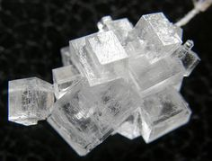
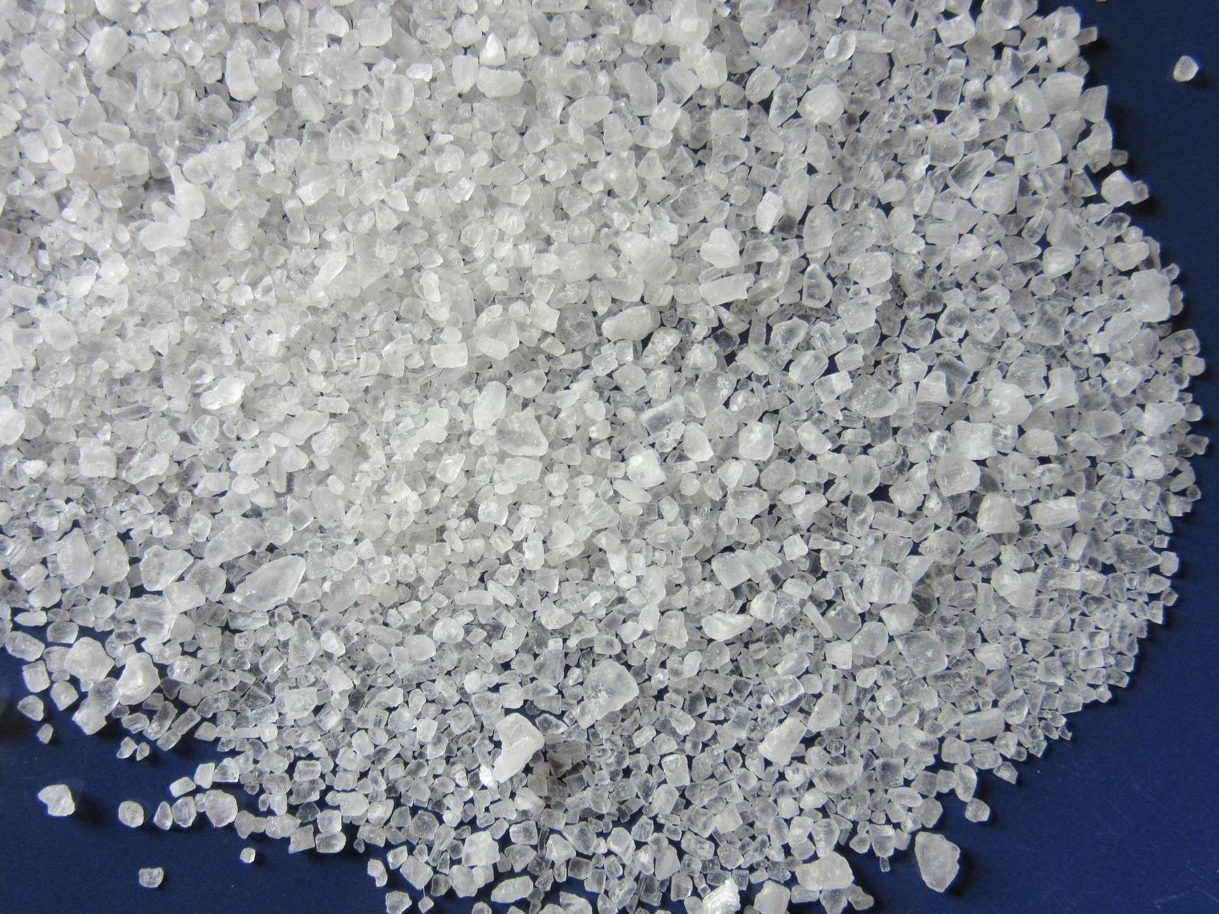
CC0 Creative Commons
Free for commercial use
No attribution required

