Title: | Sea Shells – Antacids of the Ocean
Author:  Title and Organization: | Jacqueline Erickson  Senior Development Scientist, GSK Consumer Healthcare
☒ 4th -- -6th grade (activity)
☒ 7th – 9th grade
☐ 10th – 12th grade

Flesh Kincaid Reading Level: | 8.1
Safety Suggestions: | ☒ Safety Goggles Required  ☒ Protective clothing suggested  ☒ Do not eat or drink any of the materials used in this activity  ☒ Thoroughly wash hands after this activity
Introduction of activity:
Have you ever wondered what coral or seashells are made of? Coral and some seashells contain a mineral called calcium carbonate. Did you know that these can be affected by increased carbon dioxide in the air?

Materials:
2 Small clear disposable cups or other container (4 oz.)
Markers to label the cups
Chewable Calcium Carbonate Antacid tablets (colored tablets preferred)
Seltzer water
Tap water

Procedures:
Place one chewable calcium carbonate tablet in each cup. Label the cups “Tap Water” and “Seltzer Water. Add 2 oz. of tap water to one cup and add 2 oz. of seltzer water to the other cup. Observe what happens. Is there any difference in how fast one tablet dissolves? Record your observations at one minute, two minutes, and three minutes, using the Data Table.

How does it work? / Where’s the chemistry?
Regular tap water is neutral or slightly basic (pH about 7). However, when carbon dioxide is added to water to create the bubbles in seltzer water, carbonic acid is formed, which lowers the pH of the water making it acidic (about pH 4).
Calcium carbonate is a base that reacts with the acid in seltzer water, thus dissolving the calcium carbonate tablet faster than tap water.
If there’s more carbon dioxide in the air, the ocean will absorb carbon dioxide, making it more acidic. Chemists call this process “acidification.” This simple experiment demonstrates that dissolving more carbon dioxide in water could destroy seashells or coral, as they are made of calcium carbonate.

What did you see?
Data table
Observation Time | Tap Water | Seltzer Water
One minute
Two minutes
Three minutes

pH Scale:

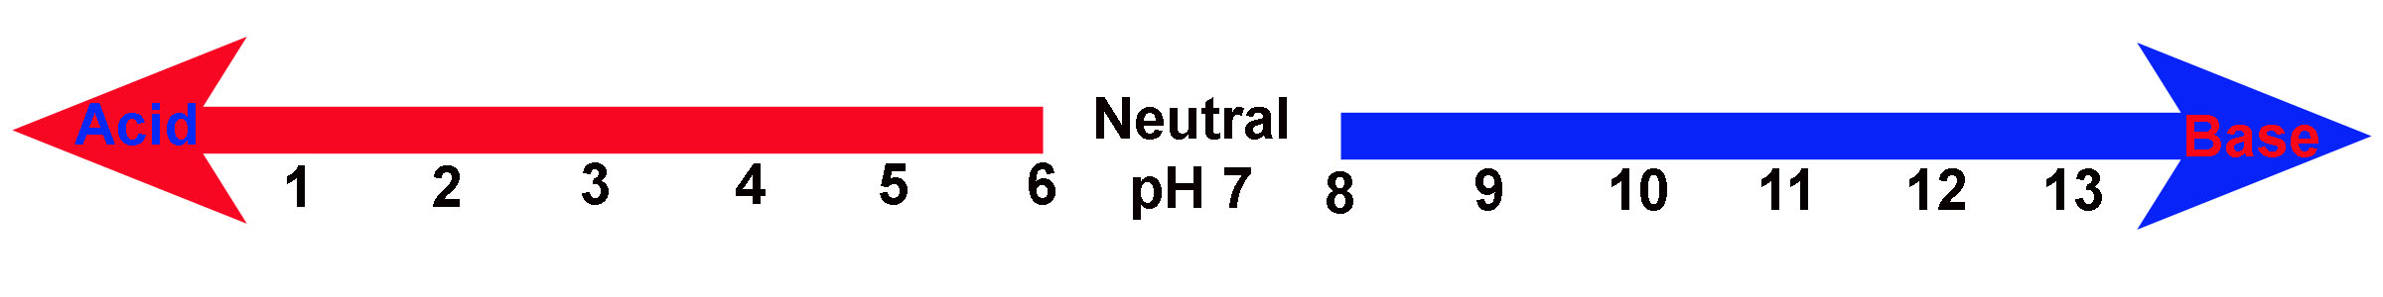

References:
Please acknowledge if this activity was adapted from another publication and its source. Please list any references used. Please give a reference for any figures or pictures used, unless you yourself are the artist.
Artwork will be added to this activity to enhance the look and feel. You may optionally attach any suggested artwork for this activity. NOTE: It is your responsibility to secure copyright permission for any artwork/photographs that you suggest.

