Title: | Seaweeds: The Marine Chemists
Author:  Title and Organization: | Sheila Kanodia and Cary Supalo  Forensic Scientist at DHS / Independence Science
Age Appropriateness: | ☒ 4th -- 6th grade  ☐ 7th – 9th grade  ☐ 10th – 12th grade
Flesh Kincaid Reading Level: | 6.0
Article Text:
Seaweeds: The Marine Chemists

What looks like a plant but has no roots, stems, or flowers, and lives in water? If you guessed seaweed, you are right. This amazing family of algae has more than 10,000 members across the world. Some types are microscopic in size, while giant kelp can grow 2 feet a day. Underwater forests of giant kelp can be 40 feet high. Seaweed provides food and homes for many fish, abalone, crabs, and sea otters. Seaweed is strong and can help protect ocean habitats from wave damage. Seaweed is an ecosystem chemist. It uses photosynthesis to turn sunlight into chemical and metabolic energy. They also make most of the world’s oxygen, which we need to breathe.

Seaweed is found in many colors and shapes. The major colors are red, green, and brown. Red seaweeds like cold water, and green seaweeds prefer tropical waters. Both live close to the shore. That is where the water isn’t too deep for sunlight to reach the seaweed. Seaweed needs light to grow, capturing carbon dioxide from the water and releasing oxygen. This process is called photosynthesis, and only plants can do it.

The shore also has rocky places for the seaweeds to hold onto. The largest seaweeds are brown, and are tall enough to reach the light in deeper water miles away from the shore. Sargassum is a type of seaweed that doesn’t have to anchor itself. It uses gas-filled sacs to help it float. Other types of seaweed can survive in tidal pools, where the temperature, salinity, and water levels can change quickly. The names of different seaweeds give us clues about their shapes. What do you think feather boa kelp looks like? Or sea lettuce?

Seaweed has many uses. It is used for medicine, fertilizer, food, and possibly (in the future) fuel. Seaweed gives us fiber and many important vitamins, trace elements, and minerals we need for good health. These minerals include calcium, magnesium, potassium and iodine. Seaweed has been used to keep wounds from getting infected. It may also help in treating cancer.

Some people call seaweed a sea vegetable. People who live near the ocean discovered how to use it as food. In China and Japan, people dry sheets of red seaweed to use in soups or for wrapping sushi. It is used in Wales to make laverbread. Seaweed is used to make noodles. In Belize, seaweed is mixed with milk and sweet spices to make a drink called dulce. Seaweed is found in many snack foods, including some crackers and even ice cream.

As they grow, seaweeds create many new molecules, including polymers. Polymers are giant molecules that are made by putting many small molecules together. For example, starch is made from sugar molecules. Seaweeds make polymers called “alginates.” One of the most common alginates is known as sodium alginate. This substance absorbs water easily and thus grows in size. Alginates are typically sold as powders. When mixed with water, they can be as thin as pancake batter or as thick as cream cheese. In the ocean it forms a jelly like substance. Sodium alginate provides support for seaweed to grow in water where it lives.

Have you ever been to the dentist and had to get a mold of your teeth? This was probably alginate. Dentists use alginate molds to help determine if braces are needed. Alginates are also in the foods you love to eat. Alginates give yogurt and ice cream that unique and creamy texture that we know and love.

The next time you think about the ocean, remember how seaweed helps you every day. When you take a breath, brush your teeth, or eat a healthy snack, seaweed is part of your life.

References:
https://simple.wikipedia.org/wiki/Seaweed
http://sciencing.com/seaweed-kids-8642059.html
http://www.foodmatters.com/seaweed-superfoods
http://oceanservice.noaa.gov/facts/seaweed.html
https://en.wikipedia.org/wiki/Alginic_acid

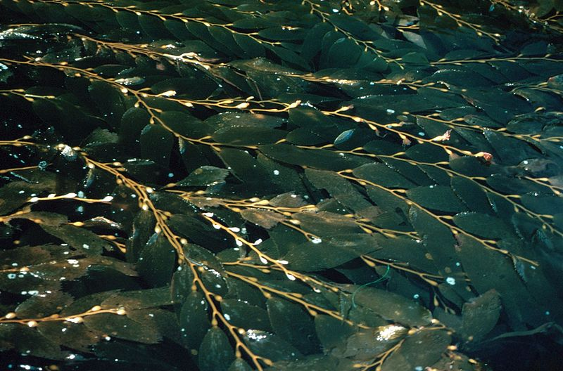
https://en.wikipedia.org/wiki/File:Giantkelp2_300.jpg
