Title: | To flush or not to flush? Chemistry makes it flushable
Author: | Janet A. Asper
Byline: | Associate Professor of Chemistry, University of Mary Washington.
Age Appropriateness: | ☒ 4th -- 6th grade  ☐ 7th – 9th grade  ☐ 10th – 12th grade
Flesh Kincaid Reading Level: | 6.5
Article Text:
As you read in “Cross-reference article” paper is made up of cellulose, which is a polymer of glucose. Think about the paper that you write on in school. What happens when it gets wet? Does it fall apart? Now think about toilet paper. What happens when it gets wet? Does it fall apart? If both of commonly used items are paper, and are made of the same chemicals, why do they behave so differently?
The difference is in the length and kind of molecules making up the paper fibers. The cellulose fibers in toilet paper are very short. When toilet paper gets wet, the water is attracted to the OH groups on the cellulose, causing the paper to swell and pushing the fibers apart. Add a little bit of stirring (FLUSH!) and the paper breaks up into tiny pieces that are easily carried through the pipes and to the sewage treatment plant.
But what about baby wipes? They are used to wipe the same “stuff” off of the same part of the body? Why don’t we flush those? The difference is in the chemistry. Baby wipes use a different molecules including long fibers of polypropylene, polyester and rayon. These fibers make the wipes really soft (soft as a baby’s bottom!) but do not attract as much water because they are made up of different atoms. And because the fibers are much longer, the wipes do not break up into tiny pieces.
When you flush baby wipes, these larger pieces don’t move through the pipes as well. They aren’t carried by the flow of the water. They bunch up together and attract oils and fats in the wastewater. This is because “like dissolves like”. Although the cellulose attracts water (insert figure) the polypropylene in baby wipes is made up of carbon and hydrogen atoms. This attracts fats and oils. The oils stick to the baby wipes, and then the baby wipes begin to stick to each other, attracting more oil. This makes a gooey, insoluble glob called a “fatberg”. The fatberg can grow and grow, clogging drains and sewer pipes. Many cities are very worried about fatbergs because they are very difficult (and disgusting) to remove. In 2017 a 130 ton fatberg was removed from the sewers in London, England. It is now on display at the Museum of London.
.

References:
https://www.cnn.com/2018/01/18/world/museum-of-london-fatberg-exhibit/index.html

Images:
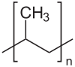 polypropylene (public domain) https://en.wikipedia.org/wiki/Polypropylene#/media/File:Polypropylen.svg
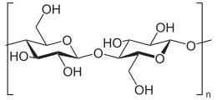 Cellulose (public domain) https://en.wikipedia.org/wiki/Cellulose#/media/File:Cellulose_Sessel.svg
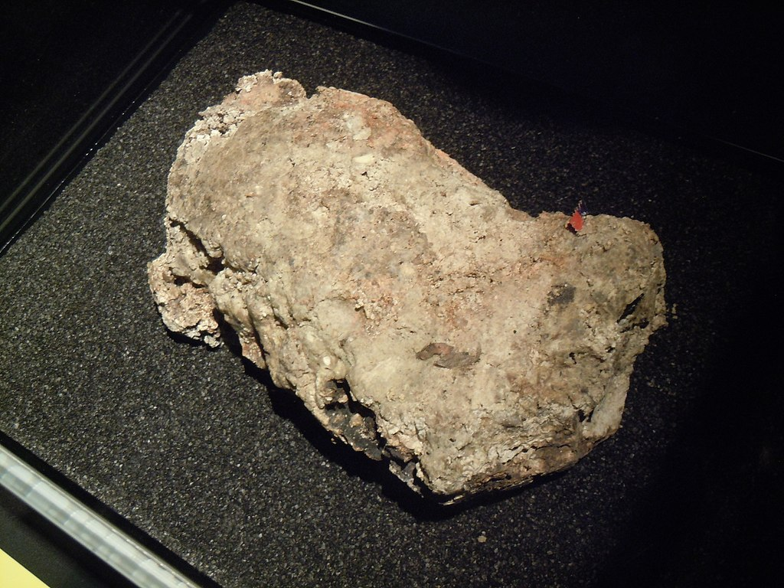
A dried section of the Whitechapel fatberg, on display at the Museum of London. Lord Belbury
https://en.wikipedia.org/wiki/Fatberg#/media/File:Fatberg_at_Museum_of_London.jpg Creative Commons. Can be reused with attribution.
.

