- Harvesting: Wood from sustainably managed forests is harvested.
- Chipping: Bark is removed from logs, and the logs are broken into small pieces.
- Pulping: Wood chips are ground into fibers. Sodium hydroxide and sodium sulfite can be added to a mixture of these fibers with water and heated to remove lignin.
- Recycling: Paper is collected and dissolved into pulp to separate the fibers.
- De-inking: Adhesives, ink, and other impurities are removed from the pulp.
- Cleaning: The fibers are washed, and bleaches can be added to whiten the fibers.
- Spraying: A slurry of fibers in water is sprayed onto a wire mesh conveyor belt to form a thin mat of fibers.
- Pressing and drying: Water is removed by squeezing and heating the mat to produce a continuous sheet of paper that is rolled onto large reels.
- Coating: Coatings, pigments, and additives can be added to the paper surface to achieve certain properties.
- Calendering: The coated paper is pressed and heated once again to smooth its surface.
- Finishing: The paper rolls can be cut into sheets or smaller rolls for use.

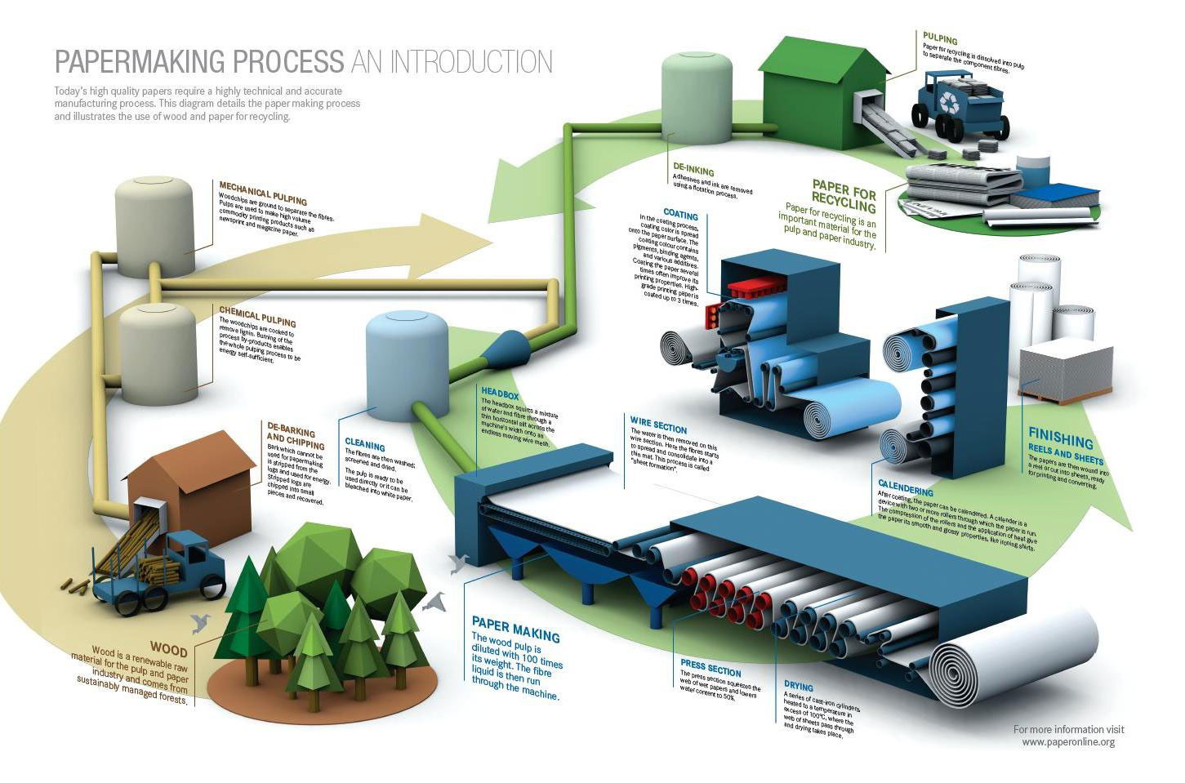

http://www.csun.edu/~pjd77408/DrD/resources/Printing/PaperMade.html
http://www.madehow.com/Volume-2/Paper.html
http://www.paperonline.org/paper-making/paper-production

