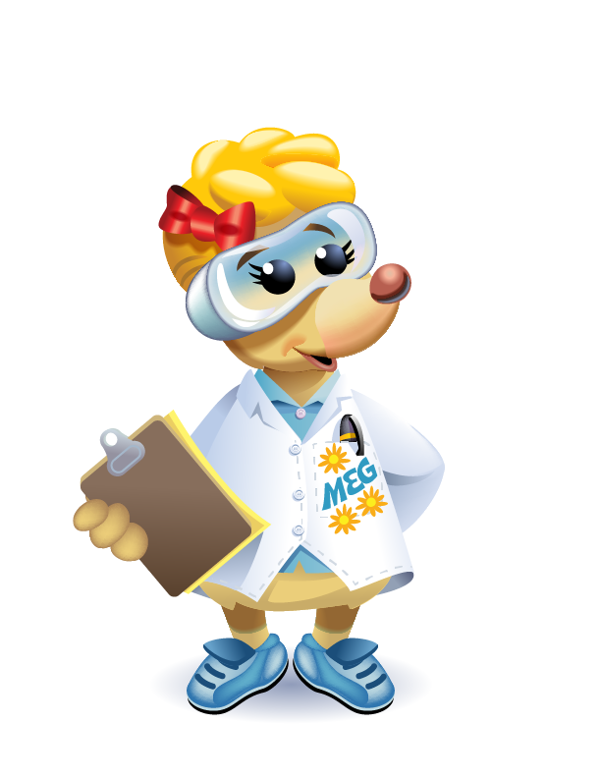
Meg A. Mole Interview Questions

Please answer the three questions in the basic info category.
Then respond to at least two items in each of the remaining categories.

Basic Info (Please complete each of the questions in this category.)

- What is your name?

- Where do you work?

- Describe in simple terms the kinds of things you do in your work. Please mention any noteworthy and or exciting things that visitor might see you do during a visit. Also, mention any special equipment that you must use/wear to complete your projects.

For example:
I mix chemicals together to make new products like plastic.
I try to find ways to make a product like glue work better.
I test products to make sure they work well and that they are safe.
I wear an outfit that looks like a spacesuit.

Your Background (Please answer two or more questions in this category.)
- Were you interested in science when you were growing up?
- What kinds of science experiments did you do at school or at home when you were young?
- Did your parents and teachers encourage you to do science experiments and projects?
- What made you decide to go into science?
- What subjects were your favorites in school?

Your Job (Please answer two or more questions in this category.)
- What do you like about your job?
- What is the best thing about being a scientist?
- Describe where you do most of your work.
- Where would a child come in contact with some aspect of your work?
- How could your work apply to a child’s life?

Fun Facts About You (Please answer two or more questions in this category.)
- Favorite food/color/movie
- Favorite pastime/hobby
- Accomplishment you are proud of
- Birth date, not year
- Very interesting project you were a part of
- About your family

