Updating an “Activity + Pages” Sub-forum on the ACS Network

Table of Contents:
- Key Terms & Definitions – p2
- Editing Banner Design and Site Photo – p4
- Creating a Page – p5
- Editing a Page – p5
- Adding, Editing, or Deleting a Tile – p6
- Creating Content – p10
- Editing Content – p10
- Creating Categories – p10
- General Notes – p11
- Recommended Reading – p11

The purpose of this document is to instruct Network users and section webmasters on how to interact with, edit, and manage a sub-space on the ACS Network with a specific navigation configuration of “Activity + Pages.”

Key Terms & Definitions:
Space/Forum – This is a place within the ACS Network that acts as a website for local sections, technical groups, and other communities. Forums can be made public or restricted to certain users via permissions controlled by admins of the space. If a space is created within a main forum, that place is called a sub-forum or sub-space. The action of creating sub-spaces within parent forums is called nesting.
- Note: Only WSO can create a Forum/space. Contact them if you have the need to set one up.
Group – A group is an alternative type of Network space to a forum and it can be created by anyone. Groups can be made public, restricted, or private. When Private, a group is accessible to users via invitation only.
- Note: We are encouraging the use of forums as there is more control and we think they are easier to support in the future.
Permissions – These are the settings prescribed to a specific forum or space that define whether or not a user, or group of users, is granted access to that place. A recently created sub-forum will inherit the permissions of the main forum it is in. Editing the permissions of a forum can make that space public or restricted, as well as give different users different capabilities in regards to viewing and editing the space.
Navigation – This defines the configuration of the sub-space and can be changed by an admin at any time. There are three types of different navigations; the one focused on in this document is the “Activity +Pages” navigation
- “Activity + Pages” – Configures a stream-driven Activity page for the place, plus additional custom-created pages in a tabbed view. The left-hand tab is the default landing page.
    - Pages are different ways of exposing content (with your content being blog posts, documents, discussions, events, etc.)
    - This scheme is usually utilized for more complex sites that contain a lot of content. The content can be better organized using pages.
- “Overview” - Configure a widget-based Overview page as this place's landing page.
- “Activity + Overview” - Configure both an Activity page and an Overview page, either of which can be the landing page.
Landing Page – The page that is automatically displayed when navigating to a specific sub-space (the default page). When utilizing the “Activity + Pages” navigation, the landing page is usually set to be the page titled “Home,” but when using either of the other two navigations, the Overview page is generally designated as the landing page.
Tiles – Tiles are tools used to layout and expose content in a space on the Network. There are a variety of different types of tiles, each with their own respective function, but in general, they display specific types of content and allow users to interact with the site (ask questions, view videos/images, etc.).
- Widgets – Similar to tiles in the sense that they are tools used to design a Network space by displaying content and interacting with the space’s users. However, widgets are available only on the Overview page and are therefore not a concern when the page is set up to have an “Activity + Pages” Navigation.
Tags – Key, identifying words that organize content so that is more easily searchable by Network Users. Tags are able to be applied to a piece of content at any time and will never be displayed anywhere on a page. They are able to be used anywhere across the network and a single piece of content can carry numerous tags.
Categories – A way of organizing a specific space’s content into differentiable groups. Unlike Tags, categories must be created prior to applying them to content (opposite order for applying tags), and categories can be displayed on pages within a space. Additionally, while tags are used anywhere in the Network, Categories are specific to a group or forum.
Actions – This refers to a list of things a site user can do to impact the sub-space they are using. Some of these actions include creating content (such as a document, discussion, blog, etc.), sharing spaces, or sending content vCards via email. A more thorough description of the content users can create with the “Actions” list is included below:
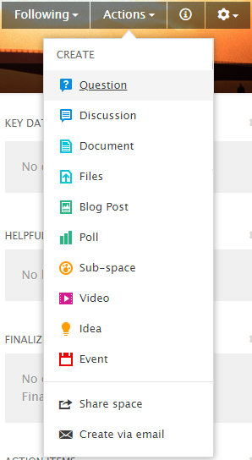
Content
Question – Used to ask a question.
Discussion – Fosters collaboration and conversation among site users.
Document – Creates a document; can contain text and/or images. Usually used for static content.
Files – Uploads files from computer to LS sub-space.
Blog Post – Creates a blog post. Blog posts will be displayed on the overview (landing/default) page in chronological order as they are posted (as long as the page contains a “recent Blog Posts” widget). Used to share announcements.
Poll – Starts a poll that site users can answer. Good way to gather information of users’ preferences.
Sub-space* – This is a way to create a sub-forum to the main forum that is your website. This is only recommended when there is significant content that needs to be segregated from the main content. Permissions can be applied to control access to this area.
Video – Imports online videos to sub-space via URL.
Idea – Publishes Idea that others can comment on. Encourages ideation among users.
Event – Creates an event that will be displayed in the events tab and any “upcoming events” widgets or tiles.

*Forums and Sub-spaces can only be created by administrators; therefore, for most users, this will not be an option accessible via the “Actions” list.

How To:
- Edit Banner and Website Photo: You have the option of changing the banner and image at the top of your website.
  - Editing the forum’s profile image
    - Click on the gear icon on the right side of the site’s banner. Access its dropdown list and select “settings.” A small window will appear that allows you to edit the Site’s Name, description, tags, and “Place Navigation.”
    - Exit the settings window that pops up and click on the blue button that reads “Place Image” underneath the current profile image.
    - Find and select the desired photo from your computer.
    - Save the edit by clicking on the blue “save” button in the bottom left corner of the window.
  - Editing the forum’s banner
    - Click on the gear icon in the right of the banner. Access its dropdown list and select “settings.” A small window will appear that allows you to edit the Site’s Name, description, tags, and “Place Navigation.”
    - Exit the settings window that pops up and click on the blue button that reads “Banner Design” in the top right corner of the Banner.
    - Select the desired custom or preset banner design.
    - Save the edit by clicking on the blue “save” button in the bottom left corner of the window.
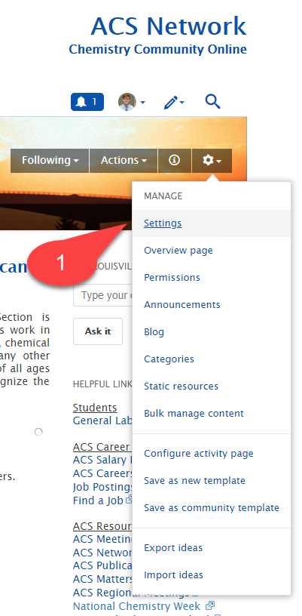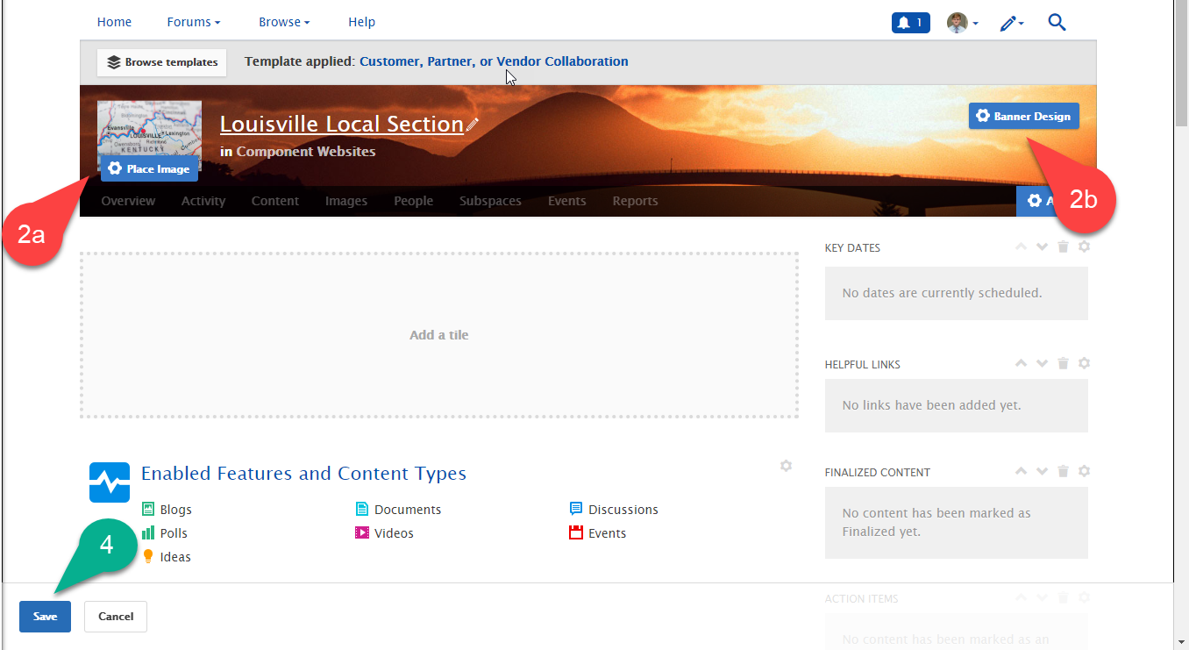

- Create a Page: A total of 5 customizable pages are available when using the “Activity + Pages” Navigation. Each page will receive its own tab located at the bottom of the site’s banner and will display its own content.
  - Adding pages to your Forum
    - Click on the gear icon on the right side of the site’s banner
    - Find and click on the “Create a page” option within the “Manage” drop down list that appears.
    - Use the small window titled “Create a page” to name your page and choose its layout.
    - Once satisfied, click the blue “OK” button to access the new page.
    - In order to save the page, you must first add at least one tile. Once complete, click the blue “Save” button in the bottom left corner of the page.
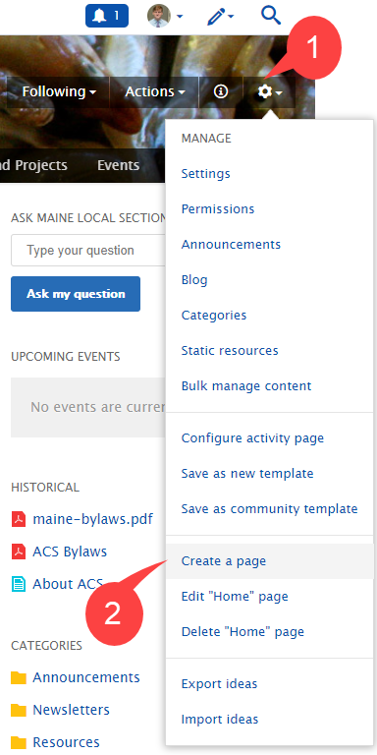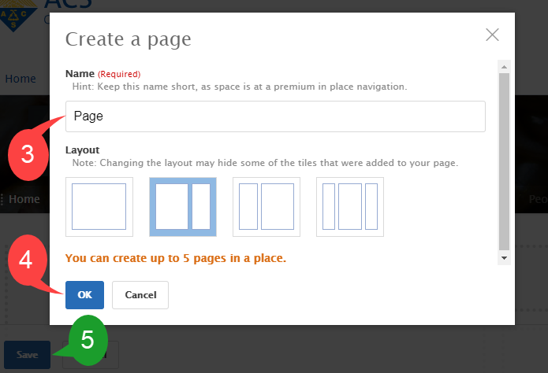

- Edit a Page: If at any time, you are unhappy with the layout or design of a page within your site, you can always change it. However, changing the layout of a page may result in the loss of tiles that you created.
  - Changing the layout/name of a page
    - First, navigate to the desired page’s “editing page.” There are two ways to do this:
      - Click on the gear icon located on the right side of the site’s banner to access the “Manage” Drop down list, and then click on the option that reads “Edit ‘[insert page title]’ page”
OR
      - Click on any gear icon located in the top right corner of an existing tile (when the cursor hovers over one such gear, it should read “configure”).
    - Click the blue “Edit Settings” button located in the bottom right corner of the site’s banner. A small window will appear allowing you to edit both the name and layout of the page.
    - Once the desired layout is chosen and the name of the page is certain, click the blue “OK” button in the bottom left corner of the window.
    - Finalize the edit by clicking the blue “Save” button in the bottom left corner of the window.
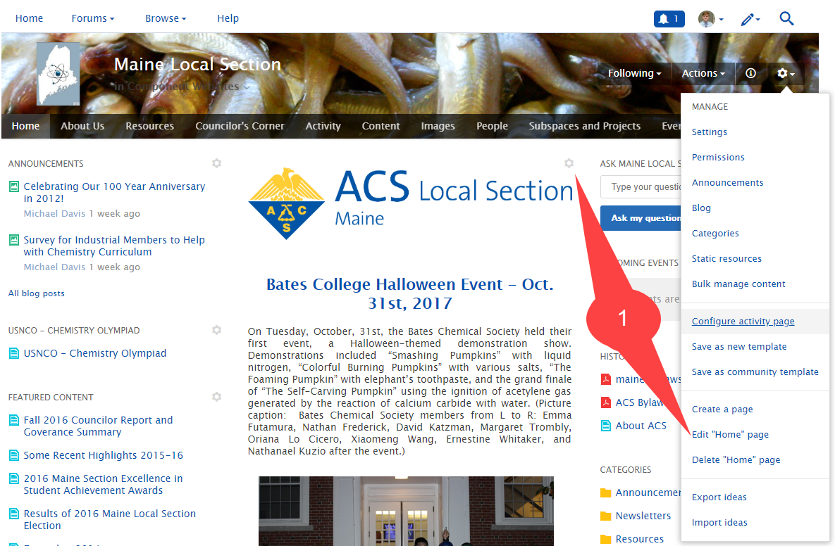
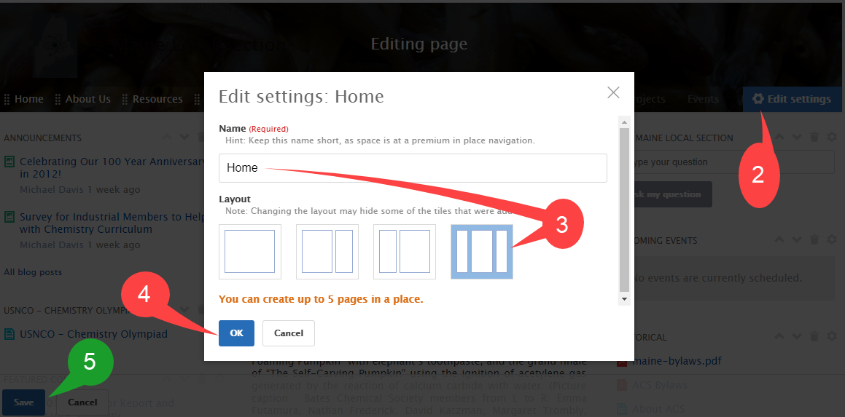

- Add, Edit, and Delete Tiles: Tiles are used to design the spaces pages by displaying content and interacting with the users of the site.
  - How to add a Tile to a page
    - Navigate to the “editing page” on which the page’s layout and design can be changed (see step i of “How to edit the layout of a page” above)
    - Click on any of the outlined, gray boxes dispersed throughout the page that reads “Add a tile”
    - Choose the type of tile desired for that location (Do this by choosing a tile category and then the tile itself).
    - Use the editing box to set up the new tile, and once finished editing, click on the apply button in the bottom of the box.
    - Once the tile is edited and applied, make sure to save the addition by clicking the blue “Save” button.
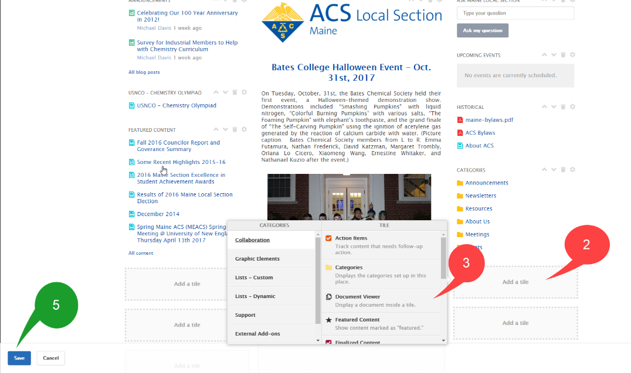
  - How to add a HTML Tile to a page
    - Navigate to the “editing page” on which the page’s layout and design can be changed (click on the small gear icon in the top left corner of any tile)
    - Click on any of the outlined, gray boxes dispersed throughout the page that reads “Add a tile”
    - Choose the tile category “External Add-ons” and then choose the Tile “Create an HTML Tile”
    - Use the editing box to set up the new tile, and once finished editing, click on the “submit” button in the bottom of the box.
    - Once the tile is edited and applied, make sure to save the addition by clicking the blue “Save” button.
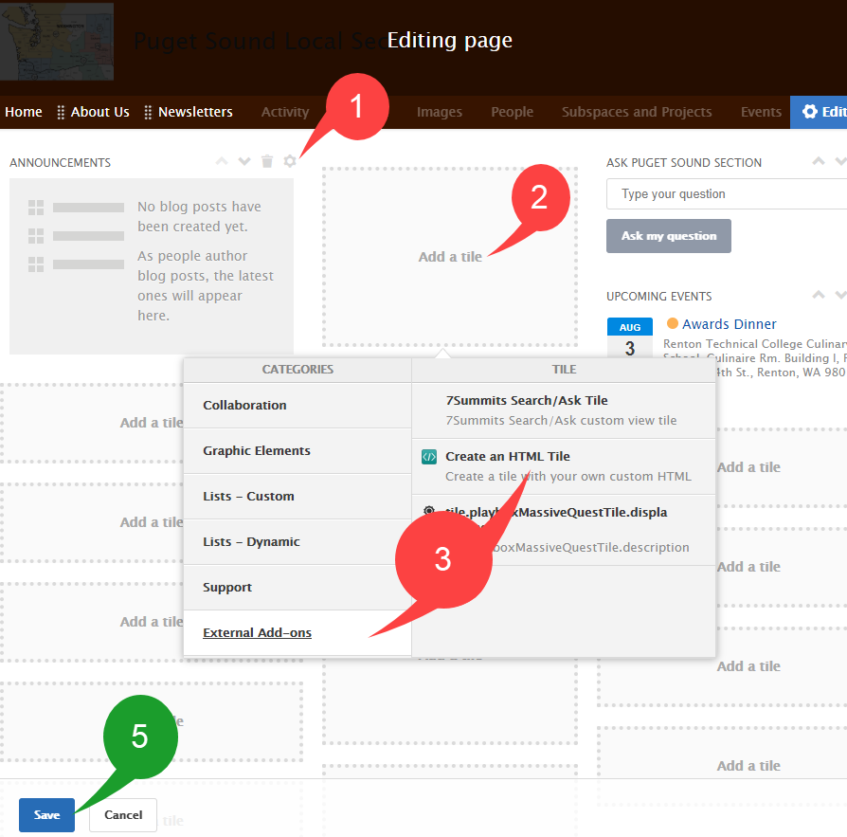
*Note: HTML tiles can be used to display a button that can link to an external E-commerce service, such as paypal.
  - Editing a Tile
    - Click on the small, gray gear icon in the top right corner of an existing tile.
    - Edit the tile to the desired specifications using the editing box that appears
    - Click “Apply” in the editing box once the edits are made
    - Click on the blue “Save” button in the bottom left corner of the editing page to save the new layout.
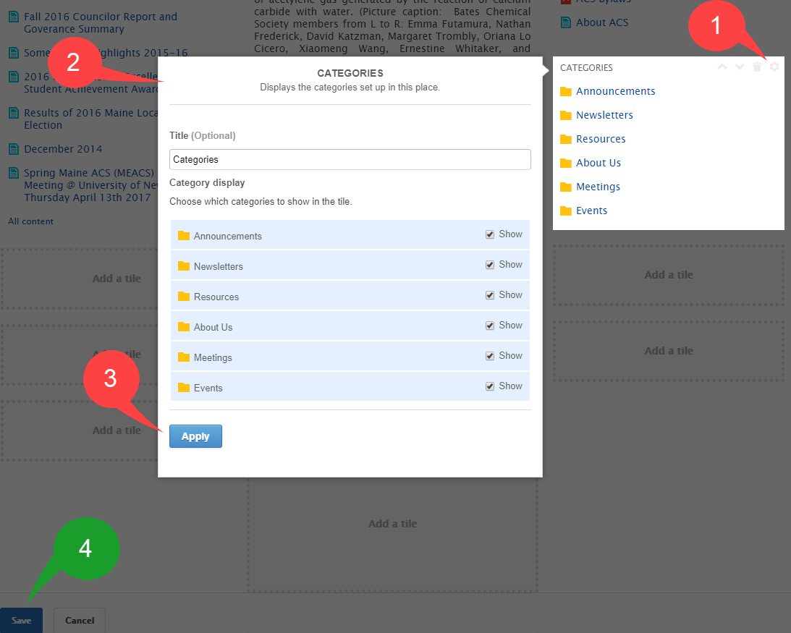
  - Deleting a Tile
    - Click on the small, gray gear icon in the top right corner of an existing tile.
    - Click on the small, gray trash icon that appears directly adjacent to the aforementioned gear icon of the desired tile. The trash icon will be to the left of the gear icon and it should read “Delete” when the cursor hovers over it.
    - Confirm that the tile should be deleted by clicking on the blue, “Delete” button on the “Delete Tile” window that appears.
    - Click on the blue “Save” button in the bottom left corner of the editing page to save the new layout.
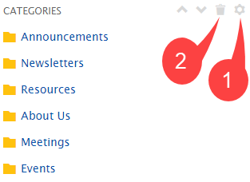
*Note: There are a limited number of Tiles per page, and their locations are determined by the layout of the page itself. Tiles can be moved up and down a column on a page by clicking on the corresponding arrows in the top left corner of the tile box.

- Create Content: There are many different types of content available on the ACS network such as blog posts, documents, files, videos, etc. Each type of content has a specific function; a list of common actions available to users is included in this document at the end of the “Key Terms and Definitions” section.
  - How to create and publish/upload content in the Network
    - Click on the “actions” drop down list in the right side of site’s banner, then select the desired content.
    - An editorial space, with instructions on how to create and edit the settings of the content will appear. Use the space and its instructions to create your desired content.
    - Publish the content in the space you desire to display it. Also, add appropriate tags to the content and consider including it in a category, so that is easily searchable by site users.
    - When finished, click the blue “publish” button at the bottom of the window.

- Edit Content: After creation and publication, content can be edited by the author at any time, and if the permissions allow it, it can also often be edited by other administrators/users as well.
  - How to Edit Content
    - Navigate to the “Content” Tab
    - Click on the title of the content (document, blog post, idea, etc.) you would like to edit
    - Click on the “edit” option above and to the right of the content preview.
    - Once editing is complete, click the “Update” button at the bottom of the page; if you do not, the content will not be saved.
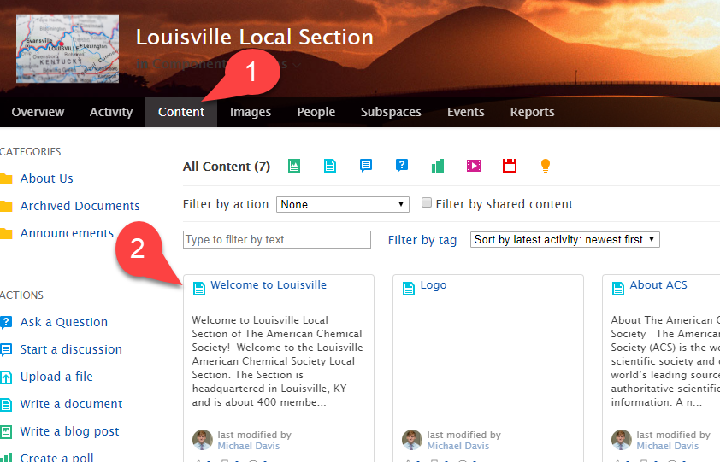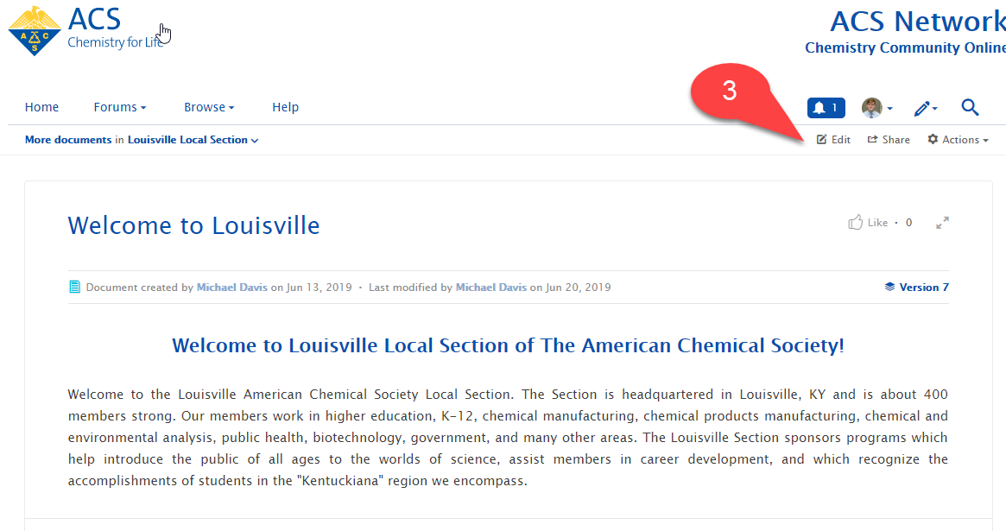

- Create Categories – Categories organize content of a specific sub-space by filing them away in groups. The categories must be created before being able to apply content to them.
  - How to create a category
    - Click on the gear icon in the top right of the window, and select the “categories” option from the “Manage” dropdown list. A “Manage Categories” box will appear.
    - Click on “Add a new category”; a new box should appear allowing you to create a new category. Give the new category a title and click the blue “save” button.
    - Click the white “Finished” button to return to the overview page
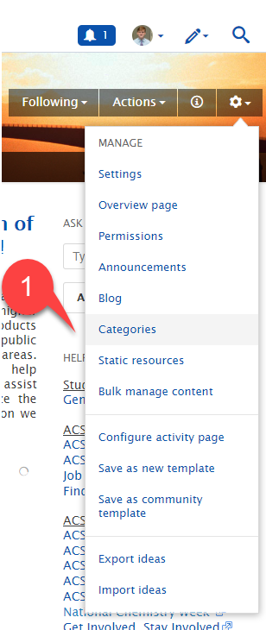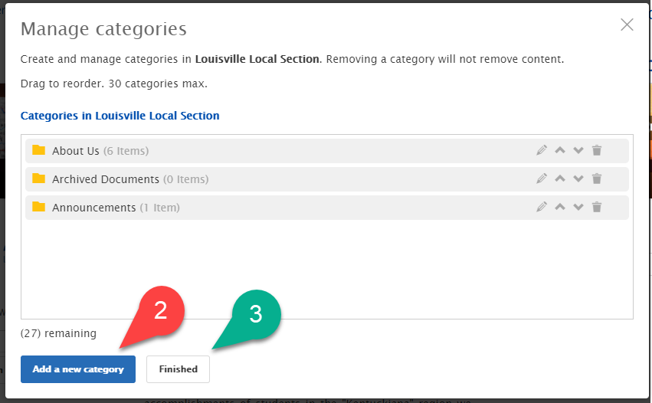
*Note: You can also alter the order the categories appear, change their titles, and delete them altogether using the “Manage categories” window shown in the screenshot above
  - Applying a single piece of content to a category
    - Navigate to the “Content” page by clicking on the “content” tab.
    - Click on the title of the content you would like to categorize
    - Click on the edit button above the content and then scroll down to the “categories” section of the “Edit this [insert content type]” page.
    - Select the check boxes to the left of the desired categories’ names.
    - Click the blue “Update” button at the bottom of the page.
  - Applying content to a category in bulk (adding multiple pieces of content to the same category at once)
    - Navigate to the “Bulk Manage Content” page (do this by clicking on “Bulk Manage Content” from the “manage” drop down list displayed after clicking on the gear icon).
    - Select the desired content by checking the respective boxes to the left of their names
    - Click on the file icon that reads “add Categories” when the cursor hovers over it; a box will appear allowing you to review the content chosen.
    - Click “continue” to proceed to the “add categories” window, and then check off the categories you would like to add the content to.
    - Click “continue” to finalize the categorization. Multiple pieces of content and categories can be chosen during this process.

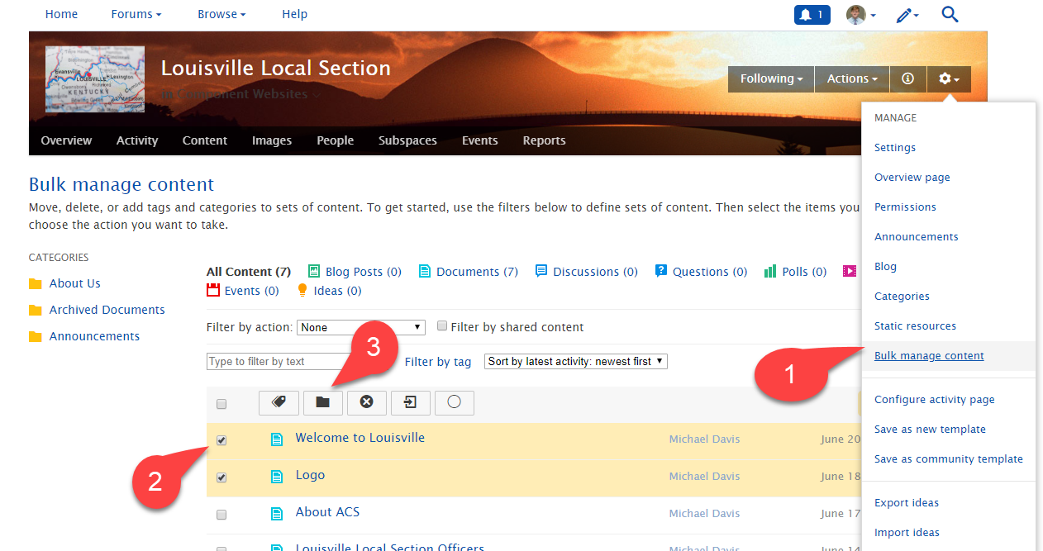

General Notes
General notes about using categories or tags: Always tag your content and add it to relevant categories! Any piece of content can be added to multiple categories, and can carry numerous tags. The use of categories and tags is intended to make content easier for Network users to find. Some helpful tags include keywords from the content being posted, the year/city/state of events mentioned in the content (i.e. national meetings), the names of people/awards mentioned, etc.
General notes for page configuring: Whenever editing tiles, be sure to click the blue “Save” button at the very bottom left of website window BEFORE leaving the site or navigating away from the page. If you forget to click this button the edits you’ve made to any of the tiles on the page will not be saved and your updates will be lost!

Recommended Reading
For additional Information on editing, updating, and moving Local Section Websites, please visit the following links from the ACS Network and review the documents included on the page.
- https://communities.acs.org/docs/DOC-70859-general-functions-in-the-acs-network
- https://communities.acs.org/docs/DOC-71982-members-permissions
- https://communities.acs.org/docs/DOC-70860-recommended-tools-for-designing-a-streamline-groupforum
- https://communities.acs.org/docs/DOC-71890-migrating-from-webscom-to-the-acs-network-wabash-valley-example’
- www.acs.org/webhosting

