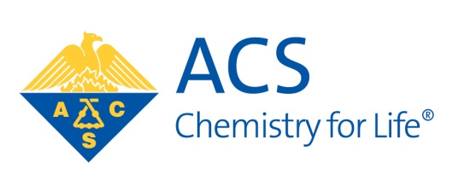
American Chemical Society
East Texas Section
October 2016

Next Section Meeting
Date: Tuesday, October 11
Place: Murphy 102
East Texas Baptist University
Marshall, TX

Dinner: On your own
Time: Speaker 7:00 P.M. (No charge for the talk)

Bringing the Next Product to a Shelf Near You
Dr. Dawn Mason
Technology Manager
Eastman Chemical Company, Kingsport, TN

Abstract
Ever wondered how the different parts of an organization work together to get products to market? Would you like to hear a success story along those lines? If so, come listen to the story of how Eastman Chemical Company commercialized Omnia™, an environmentally friendly, non-toxic industrial cleaner.

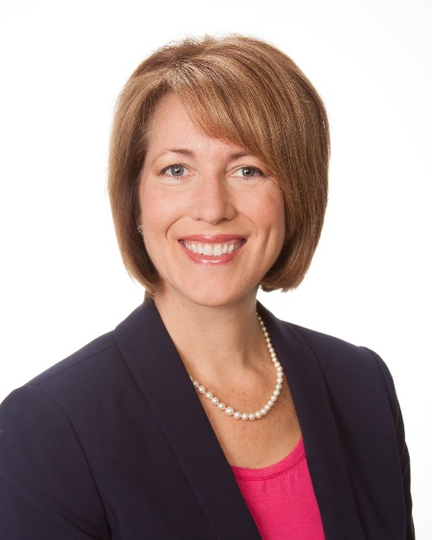
Speaker Bio
Dawn Mason is currently a Technology Manager at Eastman Chemical Company in Kingsport, Tenn., where she is responsible for managing a multimillion-dollar technology portfolio for the Specialty Films business. Since her arrival at Eastman in 2003, Mason has been a key contributor across a broad spectrum of areas that range from serving as a principal research chemist to building a career development matrix that enhances workforce capabilities, employee engagement and future leader capability. Prior to her arrival at Eastman, Mason worked with E. I. DuPont de Nemours & Co. as an area superintendent and R&D chemist, and she was part of an effort to institute a Laboratory Safety Management program at DuPont. Mason earned her B.S. from the University of Missouri-Columbia and her Ph.D. from Texas A&M University with Marcetta Darensbourg. Some of her other managerial areas of focus during the last 10-plus years have included a variety of technology groups that contribute in areas ranging from catalysis to polymer modification and from technical service to process improvement – Mason is a Six Sigma Green Belt. In each managerial position, she has driven a safety culture which resulted in zero injuries to direct reports without sacrificing business results. She is the past chair for the ACS Committee on Corporation Associates, is a member of the ACS Leadership Advisory Board, and is on the UC Center for Laboratory Safety Advisory Board.

Upcoming Dates
October 11 Dawn Mason, Eastman Chemical, Kingsport, TN @ ETBU, Marshall
November 10-13 Southwest Regional Meeting, Galveston, TX

November is Election Time

We will be electing Chair-Elect, Secretary, and Treasurer for 2017. We also be electing a Councilor and an Alternate Councilor for the term of 2017-2019. Ballots will be mailed in November.

If you have a nomination or would like to run for an office, contact Bruce Hathaway (BruceHathaway@letu.edu) prior to November 1.

2016 Section Officers

Chair Bruce Hathaway BruceHathaway@letu.edu
Chair-elect Mike Sheets mike.sheets@texarkanacollege.edu
Treasurer Paul Zhang pzhang@ana-lab.com
Secretary Mike Sheets mike.sheets@texarkanacollege.edu
Councilor Mike Sheets mike.sheets@texarkanacollege.edu
Alt. Councilor Philip Verhalen philip.verhalen@gmail.com

Webmarm Kristin Butterworth kmb681@gmail.com

Section Website: http://easttexasacs.sites.acs.org

Upcoming ACS Webinars

The Chemistry of Life: Treating Cancer with Nanoparticles Powered by the Sound of Light
Thursday, October 6, 2016 @ 2-3pm ET
https://www.acs.org/content/acs/en/acs-webinars/technology-innovation/nanoparticles.html
How can we improve the modern methods of cancer treatment? Join Justin Harris of NanoHybrids as he discusses revolutionary non-invasive methods like Photoacoustic imaging and Photothermal therapy that allow for the development of molecularly-targeted nanoparticles to detect diseased tissue. The unique design of nanoparticles allows for the visualization and treatment of diseased tissue at the cellular level, especially with cancer, minimizing the typical nasty side effects of chemotherapeutics, radiation, and surgical removal.

Failure: Why Science Is So Successful
Thursday, October 13, 2016 @ 2-3pm ET
https://www.acs.org/content/acs/en/acs-webinars/popular-chemistry/failure.html
Science since Galileo has been a remarkably successful method for understanding the universe. One reason for this is the particular way in which Science uses failure to progress. Join best selling author Stuart Firestein for a discussion on how science is an iterative process in which revision is a victory and failure is critical to its continued success.

Cosmetic Chemistry: Novel Approaches using Natural and Renewable Ingredients
Thursday, October 20, 2016 @ 2-3pm ET
https://www.acs.org/content/acs/en/acs-webinars/popular-chemistry/cosmetic.html
Nobody can deny that nature makes amazing chemistry. However, many naturally-derived ingredients are appearing more and more in cosmetic products these days with little understanding of their activity or composition. Join Richard Blackburn of the University of Leeds and Keracol Limited as he investigates the possibility of isolating actives from plant materials using green chemistry principles as well as how to find applications for these actives to produce both sustainable and functional cosmetics.

Chemistry of Life: Instantly Treating Wounds with Hemostatic Gel
Thursday, November 3, 2016 @ 2-3pm ET
https://www.acs.org/content/acs/en/acs-webinars/technology-innovation/hemostatic.html
In emergencies, quickly dressing a wound can be criticaland even lifesaving. Join Joe Landolina of Suneris, Inc. as he shares theprogress being made with hemostatic gel that can stop bleeding in seconds rather than minutes using traditional closures. He will also highlight the potential impact of this technology to multiple diverse industries.

About ACS Webinars™
ACS Webinars™ is a free, weekly online event serving to connect ACS members and scientific professionals with subject matter experts and global thought leaders in chemical sciences, management, and business. The ACS Webinars are divided into several series that address topics of interest to the chemical and scientific community; these series include careers, business and innovation, professional growth, joy of science, extreme chemistry, entrepreneurial initiative, green chemistry, and more. Each webinar is 60 minutes in length, comprising a short presentation followed by Q&A with the speaker. The live webinars are held on Thursdays from 2-3pm ET. Recordings of the webinars are available online and upcoming events are posted at http://acswebinars.org/.

