
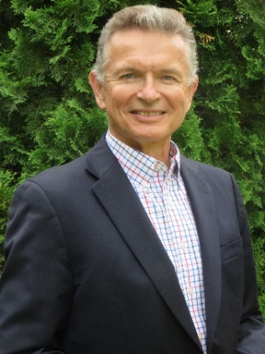
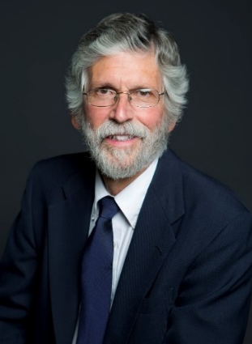

MEET THE CANDIDATES
for

ACS PRESIDENT-ELECT 2019

LUIS A. ECHEGOYEN THOMAS R. GILBERT
Monday, August 20, 2018

1:00 - 4:00 PM
Located near the Poster Session Area

ACS EXPOSITION
Boston Convention & Exhibition Center Exhibit Hall A

Sponsored by the
COMMITTEE ON NOMINATIONS AND ELECTIONS

