# ACS Lake Superior Section

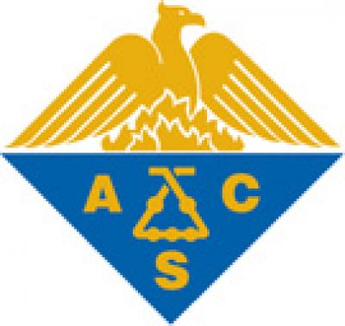

# Chemistry Club Outreach Activity Grant

|  |  |
| --- | --- |
| Contact Information | |
|  | |
| Advisor Name |  |
| Club President Name |  |
| College or University |  |
| Street Address |  |
| City, ST ZIP Code |  |
| Phone |  |
| E-Mail Address |  |

|  |  |
| --- | --- |
| Activity | |
| Describe the activity or activities that your club plans to do. | |
|  | | |
| Approximate Date(s) |  |
| Location(s) |  |
| Amount Requested |  |
| Nature of activity or activities |  |

|  |
| --- |
| Outcomes |
| Indicate how you will report the outcomes of your activity (check all that apply). Minimally, you should provide a brief (1-2 paragraph) written description of the activity including the number of volunteers helping and the number of participants attending. This should be submitted to the Local Section Chair within one month of completion of the activity. |
|  |
| Written summary |
| Photos |
| Feedback from participants |
| Other – Indicate: |
|  |

A maximum of $200 per year will be awarded to each club. Submit completed applications via email attachment to the Local Section Chair.