Lehigh Valley ACS Announces Our First Virtual Undergraduate Research Poster Session!
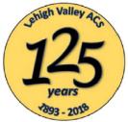
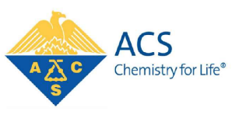
Wednesday April 15th 5:30 to 7:00 pm

Join the Webinar at: https://zoom.us/j/361271534?pwd=TlFkcUNXUE9VTGpXQjQvS2krUE5jZz09

COVID-19 has prevented us from holding our annual poster session in-person, but 5 able undergraduate scientists from Moravian College will bridge the social distancing divide with a timely discussion of chemical approaches to control bacterial communication. So lean back in your favorite armchair and learn about a fascinating aspect of biochemistry: quorum sensing!

The members of the Bertucci Group at Moravian College are conducting research to better understand the chemical factors that influence a density-dependent bacterial communication known as quorum sensing. Alec Buttner, Emilee Engler, Fadi Hanna, Liz Hutnick and Naomi Rieth are studying this phenomenon in the opportunist pathogen Streptococcus pneumoniae and the commensal microbe Lactobacillus plantarum through the synthesis of peptides containing non-natural amino acids. Please join us on Wednesday April 15th at 5:30pm to hear about their experiences spanning from chemistry to microbiology and even genetics in their quest to uncover how bacterial quorum sensing impacts human health.

Read their abstracts at: https://drive.google.com/open?id=157x76lBWzdHlsgkv0E375EDALXdEaUGe

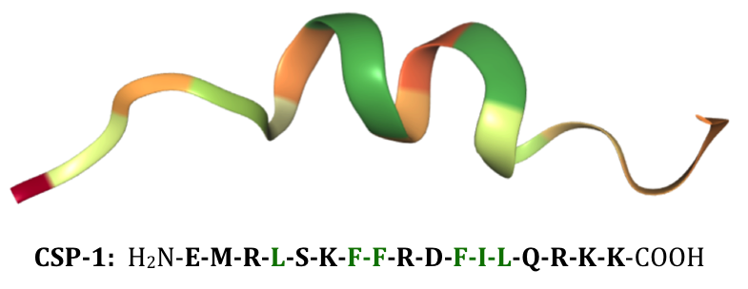
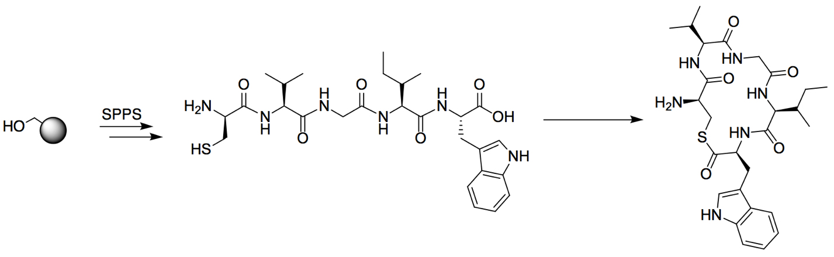

The Bertucci Group Website: https://www.moravian.edu/bertucci-group

