ACS Leadership Courses at Saint Joseph's University in Philadelphia

Join the Philadelphia, Lehigh Valley, Princeton, and Trenton local sections of the ACS for an opportunity to take two leadership development courses and participate in a networking lunch on Saturday, September 11 at St. Joseph’s University in Philadelphia. The leadership courses have been designed by chemists specifically to enhance the professional development of those in the chemical community.
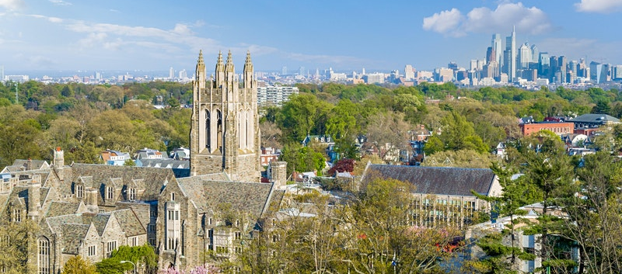
Date and time
Sat, September 11, 2021
7:30 AM – 5:30 PM EDT

Location
Saint Joseph's University
5600 City Avenue
Philadelphia, PA 19131

Register for your morning and afternoon Leadership Course with Networking Luncheon here: https://www.eventbrite.com/e/delaware-valley-leadership-development-institute-tickets-158514476065 Registration is limited and is expected to fill up quickly. Please register early to ensure course availability. Discounted tickets are available for students and ACS Members. Non-Members will receive a 50% off membership voucher following the event. Ticket prices include all fees and range from $18-82 depending on membership status.

Options for Leadership Courses include:

• Fostering Innovation: Gain the understanding and tools to help you tap into your innovation style and learn how to stimulate innovative thinking among team members and colleagues.

• Coaching and Feedback: Learn how to increase performance, expand the skills of your team, encourage creativity and improve the morale of team members.

• Developing Communication Strategies: Develop and practice your own effective communication strategy and discover how communication can make your goals possible.

• Collaborating Across Boundaries: Learn strategies and tools to be more effective in leading collaborative efforts. Gain practical skills that can be applied immediately in the lab, at school, in the office or at ACS.

