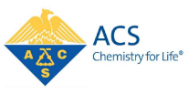
NEWSLETTER OF THE LEHIGH VALLEY SECTION SEPTEMBER 2020
OF THE AMERICAN CHEMICAL SOCIETY VOL. 103, NO. 7
THE OCTAGON
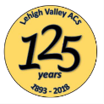

SEPTEMBER 17TH MEETING AT DA VINCI SCIENCE CENTER
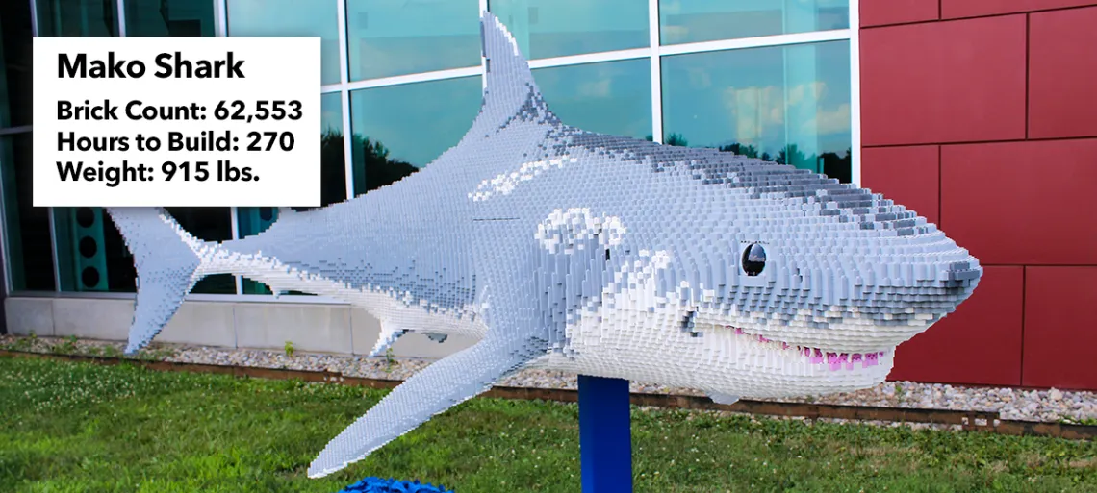

We’re hoping this big guy will help us take a bite out of COVID-19 malaise with our first mask-to-mask meeting! Join us for a tour of Da Vinci’s entirely outdoor, socially distanced, contact-free BRICKLIVE-Ocean exhibit, hear about future plans for the Center and congratulate the awardees at our delayed spring awards presentation.
Thursday, September 17th, 2020, 5:30pm – 7:30pm
Da Vinci Science Center, 3145 Hamilton Blvd. Bypass, Allentown, PA 18103

5:30-6:30 pm: welcome at tented area on the north side of the Center (next to the parking lot). We’ll collect into small groups for 45 minute tours of the outdoor BRICKLIVE-Ocean exhibit including demonstrations on global water ecology and the impact of increased atmospheric CO₂ on ocean ecosystems by Da Vinci staff. https://www.davincisciencecenter.org/
6:30-7:30 pm: reconvene in the tented area for the program.
- Da Vinci Science Center (Lin Erickson, CEO and Director; Tyler Groft, Education Director)
- LVACS (awards and short business meeting)

Meeting Fee (covers tour and demos): $12 per person.

In view of local, state and CDC recommendations, masks and distancing will be required. Water (DSC will provide Eco-friendly water or bring your own) is permitted but no other beverages or food.

REGISTER: https://docs.google.com/forms/d/1k89AwfXbB9UTy-0lw1iKz0pg4Q7GA4rT0UczBE_qook/edit?usp=sharing
CONTACT: Nigel Sanders [nigel53.sanders@gmail.com; 610-597-5645]

VOL. 103, NO. 7, PAGE 1

