LDI Resource Fair Short Survey
Annotated Questionnaire Report
Prepared by: ACS Research & Decision Support
January 29, 2019
Background
In January 2019, the LDI Resource Fair Short Survey was fielded at the Leadership Institute and via email to Leadership Development stakeholders.

Methodology
Method: Online survey
Target audience: Leadership Institute attendees
In Field: January 20, 2019 to January 29, 2019
Response rate: n=147 respondents completed the survey
Margin of error: Results are within a margin of error of: +/- 7.1%

LDI Resource Fair Short Survey Findings
Executive Summary

- Half of survey respondents indicated they identify as ‘late careerists’ (over 16 years of experience).
- Over a third of respondents feel that the current ACS leadership development offerings focus too much on volunteer development, versus career advancement.
- Slightly over a quarter of respondents indicated they’d like to see more career advancement offerings. Just over half desire a balance between volunteer development and career advancement.
- The majority of respondents expect both ACS and their company/organization to provide career advancement and professional development learning opportunities.

Results

Leadership Development Institute
Q_Screener. Which of the following best describes your career level?

QS. Career Level (Base n=127): Just over half (51%) of respondents are in their late career (over 16 years).
Career Level
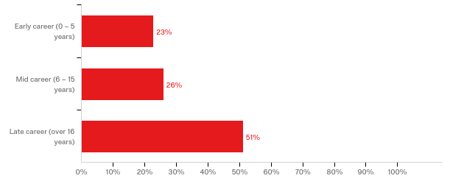
n=127

Q1. Which of the following statements best describe the current state of ACS leadership development offerings?
Q1. Current ACS Leadership Development Offerings (Base n=120): Just over half of respondents (56%) say there is a good balance between volunteer development and career advancement.
Current ACS Leadership Development Offerings

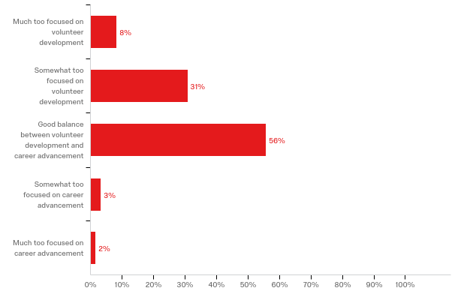
n=120

Q2. Which of the following statements best describe your desired future state for professional development offered by ACS?
More focused on volunteer development [GO TO Q2B]
Somewhat more focused on volunteer development [GO TO Q2B]
Good balance between volunteer development and career advancement [GO TO Q3]
Somewhat more focused on career advancement [GO TO Q3]
Much more focused on career advancement [GO TO Q3]
Q2. Desired Future State for ACS Professional Development Offerings (Base n=121): Just over half of respondents say they desire a good balance between volunteer development and career advancement for the future state of ACS’s professional development offerings.
Desired Future ACS Professional Development Offerings

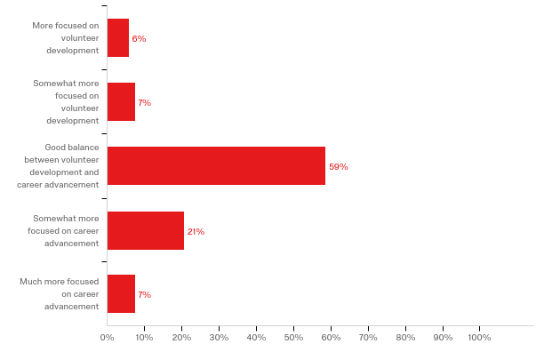
n=121

Q2b. What would you like to see ACS offer in addition to its current volunteer development offerings?

Open ended (Base n=8, doesn’t include N/A, etc.)

- Reach out to the two-year college students to get them interested in chemistry degrees and let them volunteer for local Sections. It might help them understand what they can do with a degree in chemistry or just a knowledge

- More support and training for developing ACS leaders - training for various roles and positions in Local Section and Divisions. Help to maximize the impact of volunteer commitment. help for weaker sections and divisions

- The issue I had was that the level of attendees was too broad with those with no experience and those with many years of experience.

- Knowing that these modules are offered at national meetings, I'd like to see more of a push to advertise these as a member benefit. The career development aspects are relevant to people at various stages of their careers, and there is a lot of networking that happens. And the ""volunteer development"" pieces are certainly relevant to those of us doing management--we still have to motivate people to take on tasks even when they are being paid for it, and the psychology of motivation is still applicable. I don't know that there is widespread understanding that these things are available. (I would not open the Leadership Institute beyond ACS leader participation, though, because of the need to focus on our specific challenges.)
I know this is resource limited (mostly facilitator time) but some of these could be pushed down to regional and even local section meetings to enhance visibility and access.

- Better maximization in the Maximizing Outreach Resources. It was really just an overview of current resources, which is misleading. How to maximize those resources would have had more impact for me.

- More international outreach opportunities for “everyday” volunteers - NCW coordinators, etc
More committee opportunities for non-councilors

- Easy to find and modular training that takes about 15 minutes to 30 minutes each with a focused topic or skill.

- At leadership institute should include a track on Diversity & Inclusion. It would also be beneficial to incorporate how to use Dialogue when dealing with Social Media.

Q3. Who do you expect to provide career advancement and/or professional development learning opportunities?

Q3. Career Advancement and/or Professional Development Learning Opportunities Provider (Base n=118): The majority (80%) of respondents say they expect ACS and their company/organization to provide career advancement and/or professional development learning opportunities.
Career Advancement and/or Professional Development Learning Opportunities Provider

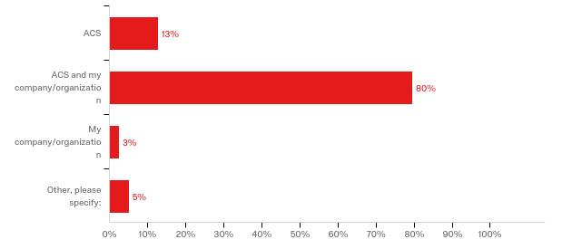
n=118

Other, please specify:
- Third party
- self-start own development and combine with ACS and my company/organization
- Non-profit or professional org
- self + organization + societies
- ACS and myself through outreach into specific areas
- And myself
Q4. About which of the following professional development topics would you like to see ACS provide learning opportunities? Please select up to three.
Q4. Professional Development Topics (Base n=117): Multi-Select – Just over one-quarter of respondents said they would like to see learning opportunities about leadership ethics (26%) and cultivating diverse and inclusive environment (26%).
Professional Development Topics
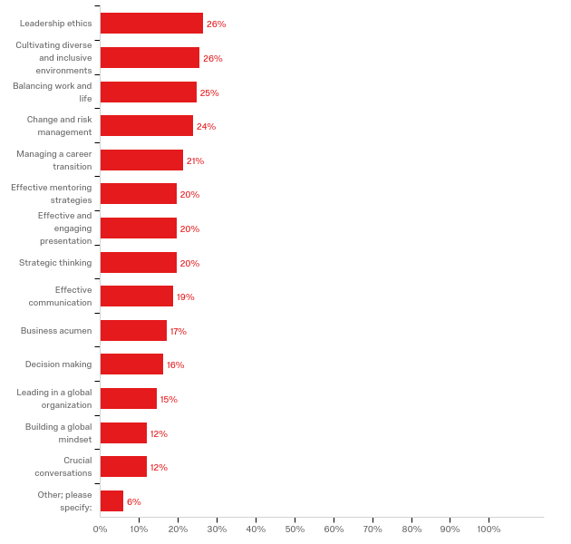
n=117

Other, please specify:
- I would shut the entire program down as it lies outside the core mission of ACS.
- I can't choose. All of these are currently missing.
- Executive coaching
- Managing complex organization finances
- Managing with ambiguous authority
- Non-academic career paths
- Engaging local (voting)population in science/chemistry

Q5. Of the following existing ACS leadership development courses, about which would you like to learn more? Please select up to three.

Existing ACS Leadership Development Courses (Base n=110): Multi-select – Of the existing ACS leadership development courses, just under one-third of respondents say they would like to learn more about managing projects effectively (32%).
Existing ACS Leadership Development Courses
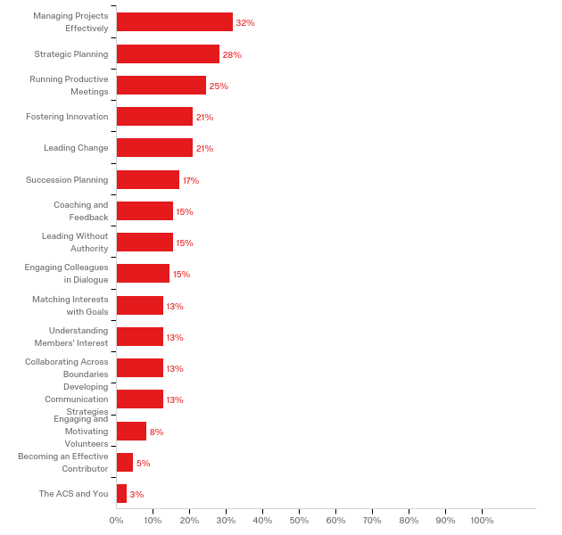
n=117

