Libraries as the knowledge and information center long for providing an engaging place for users to explore materials physically and virtually. With the advancement of information technologies, more and more materials provided by publishers and content vendors are available in digital formats, and users begin to access these via their own computers and mobile devices from internet. From libraries perspective, this helps fulfill the dream of “library without walls” (Cain, 2003) , accessing libraries within fingertips anytime and anywhere with so much convenience and mobility. The dream of the vast, authoritative, easy-to-use virtual library is not only the dream of libraries, but also our users (Mikesell, 2004). For instance, the educational model in higher education is evolving, and distance teaching-learning programs are fast growing, especially in professional trainings and continuing education areas. To better support the mission and tasks of higher education, academic libraries aim to and are required to provide equal and high quality information services and resources to all users, including all of these distance learners. Beside the convenience and mobility, users, particularly distance learners and others, have every right to remote access resources, not as a convenience, but as a necessity. Moreover, within current cyberinfrastructure, our researchers are doing multi- and inter disciplinary research at the global scales, and knowledge creation and management life cycle is drastically changed, so does the scholarly communication. To access library resources anytime and anywhere is a critical component of research and discovery, rather than just convenience, mobility and necessity.

Increasingly, this dream is being fulfilled. Libraries have worked to develop the relationships with publishers and vendors that facilitate the provision of electronic information.
“In a perfect world, network security wouldn’t exist. It’s a barrier and, generally speaking, has an inverse relationship with functionality. Librarians and other users of information systems usually find network security to be a nuisance. But just as we understand we should lock our cars when we leave them in parking lots, so we know that we must secure our networks” (Cain, 2003)
So part of this process is ensuring that access to these electronic resources is secure and available only to those for whom the licenses are purchased. Much effort has been given to the secure remote-access from libraries that collaborate with their own IT departments to ensure that the necessary trust inherent in those relationships is maintained. In fact, it is one of the most important and critical library IT supported technologies beside the integrated library systems (ILS).

In libraries and on campuses, this is a relatively simple matter, since all campus networks and workstations can be secured. This becomes more critical when accessing “off-campus”.
Technologies used in the access security have come a long way, and here are overviews of these technologies (Mikesell, 2004).

- Proxies requiring users to configure browser settings
A manually configured proxy works basically as an intermediary between the remote users and the database servers that the library makes available. It passes information back and forth from the remote users to the vendor database, making it appear as if they were working from valid IP numbers at the library rather than from their homes or offices. This is what the proxy does.

For this particular technology, users must first alter their browsers’ Internet preferences/options so that the browser knows that the user wants to connect to a proxy server and the URL of the proxy server to be used. This approach has been adopted by some libraries, but due to its inconvenience to users and the programming resources necessary to create and maintain the script properly, it was replaced by other technologies.

- Ezproxy
Instead of asking users configuring any browser to access their needed databases, EZproxy approaches this issue from library side, which operates transparently, “intervening only to authenticate and proxy data for remote patrons” (Bertrand, 2002).

According to OCLC’s overview (OCLC, 2011),
EZproxy works by dynamically altering the URLs within the web pages provided by your database vendor. The server names within the URLs of these web pages are changed to reflect your EZproxy server instead, causing your users to return to the EZproxy server as they access links on these web pages. The result is a seamless access environment for your users without the need for automatic proxy configuration files. EZproxy only alters references to your database vendors’ Web pages, so if your database vendor provides additional links to other free web pages on the Internet, these are left as-is. In this manner, if your users elect to follow one of these links, the EZproxy server is automatically taken out of the communication loop”.

This approach is adopted by more and more libraries (Murray, 2001). The main disadvantage is that the server must have a list of the URLs of resources that the library subscribes. Creating and keeping this list up-to-date requires steady maintenance for libraries, which adds on administrative cost libraries.
- Onelog
Onelog, from ITS a company from UK, is a full set of technologies package to manage, connect, report and recover costs associated with content usage (ITS, 2011). Its three modules, “password management”, “portal” and “web control”, provide seamless and transparent remote-access to users. Compared to EZproxy, Onelog brings additional benefits to libraries, especially to corporate libraries, which include (1) it takes care of configuration of all subscribed resources from libraries as part of the services, thus giving the benison of removing some administrative overheads from libraries; (2) it can be integrated with campus portal and course management system; (3) it provides the library with extensive statistics about electronic resources usage in its usage tracking and analysis modules, and (4) it gives the library full-control of users’ access to databases and resources, hence allowing library have budget control over resources. In a word, it is more than a proxy server, but a full content management package.
- Virtual Private Networks
VPNs have been widely adopted by institutions and companies for its convenience and mobility, not only for accessing library materials, but to almost any data, voice, or video application to the remote desktop, emulating the main office desktop.
“VPNs extend the institution’s IP addresses to machines outside the local area network by tunneling traffic through the general Internet. As such, VPNs work at a network infrastructure layer below that of a Web proxy server, but can accomplish the same result as a Web proxy server for remote resource access”(Murray, 2001)
The main advantage of a VPN is its high security, customizable remote access to anyone, anytime, anywhere, with almost any device. The main disadvantage is in-depth and extensive technical support required to set up and maintain the VPN (Mikesell, 2004).
- Athens
Based in the United Kingdom and supplied by Eduserv, Athens is not a proxy-based solution, but rather “the framework for managing users' identity information and enabling secure access to resources through a single username and password (single sign-on)” (eduserv, 2011).
“Athens is, fundamentally, a central repository of organisations, usernames and passwords with associated rights. It has extensive account management facilities for organisations to create and manage usernames and passwords, and to allocate rights to individual usernames” (Athens Access Management Services, n.d., Welcome to Athens section, para. 2). http://www.justispublishing.com/academic/academic.html
As an Access and Identity Management service, Athens requires publishers and vendors must cooperate with Athens protocols and be integrated into the system to fully support users’ access. This new level of cooperation, participation and support can’t be achieved by either part, but both, libraries and publishers and vendors. This approach is fundamentally different from traditional proxy access, has been adopted by libraries in UK since 1996, and is now used by over 3 million people from higher education, health care organizations, public sectors and commercial sectors (eduserv, 2011).

- Shibboleth
“The Shibboleth® System is a standards based, open source software package for web single sign-on across or within organizational boundaries. It allows sites to make informed authorization decisions for individual access of protected online resources in a privacy-preserving manner. . . . The organizations that may want to exchange information include higher education, their partners, digital content providers, government agencies, etc. The purpose of the exchange is typically to determine if a person using a web browser (e.g., Internet Explorer, Netscape Navigator, Mozilla) has the permissions to access a resource at a target resource based on information such as being a member of an institution or a particular class” (Internet 2, 2011)
Shibboleth is developed based on the cooperative methods from Athens, which means publishers and vendors must participate in the process as member of Shibboleth community and cooperate. It, however, differs from Athens fundamentally, which is its distrusted frame. Rather than having a centralized depository, an institution must install the software on its own server while also being a member of the Shibboleth community. It is based on digital attributes that are exchanged between users and vendors, which much recognize each other.

This approach is adopted by more and more libraries. In fact, more institutions adopted this approach as a parallel remote-access of VPNs, and then libraries joined their institutions besides supporting EZproxy.

- Smart card
This approach is very new in the library and information management field (Lambrinoudakis, 2000), but is used in other fields for secure access, such as ATM bank and credit cards, public transportation card (Pelletier, Trepanier, & Morency, 2011; Sheng, Tong, Song, Zhang, & Xu, 2010). Smart cards can provide identification, authentication, data storage and application processing for single sign-on with large organizations (Ahmed & Siyal, 2005; Mutsuddi, 2000; Pelletier et al., 2011; Sheng et al., 2010).

According to results from a library web proxy survey in 2001 (Murray, 2001), EZproxy server was the most adopted method in the library community. Now with the success of Athens, more and more libraries are adopting Shibboleth.
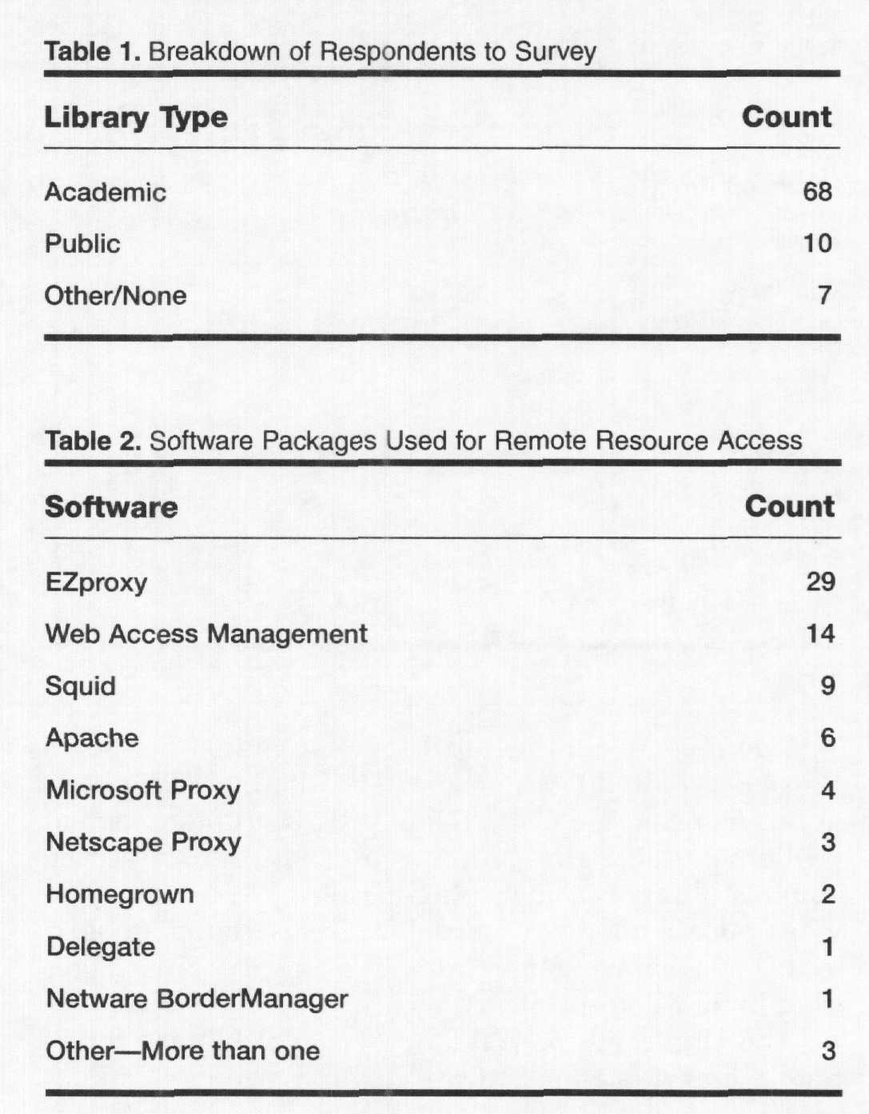

References
Ahmed, F., & Siyal, M. Y. (2005). A novel approach for regenerating a private key using password, fingerprint and smart card. Information Management & Computer Security, 13(1), 39-39-54. Retrieved from http://search.proquest.com/docview/212338217?accountid=14749
Bertrand, G. (2002). Providing access to remote patrons can be ez. Feliciter, 48(3), 134-136.
Cain, M. (2003). Cybertheft, network security, and the library without walls. Journal of Academic Librarianship, 29(4), 245-245-248. Retrieved from http://search.proquest.com/docview/57591360?accountid=14749
eduserv. (2011). Access and identity management. Retrieved 07/17, 2011, from http://www.eduserv.org.uk/aim
Internet 2. (2011). About the shibboleth® system. Retrieved 07/17, 2011, from http://shibboleth.internet2.edu/about.html
ITS. (2011). ITS : Onelog. Retrieved 07/17, 2011, from http://www.onelog.com/
Lambrinoudakis, C. (2000). Smart card technology for deploying a secure information management framework. Library Computing, 19(3), 147-147-158. Retrieved from http://search.proquest.com/docview/233603260?accountid=14749
Mikesell, B. L. (2004). Anything, anytime, anywhere: Proxy servers, shibboleth, and the dream of the digital library. Journal of Library Administration, 41(1), 315-315-326. Retrieved from http://search.proquest.com/docview/57594819?accountid=14749
Murray, P. E. (2001). Library web proxy use survey results. Information Technology and Libraries, 20(4), 172-172-178. Retrieved from http://search.proquest.com/docview/215832929?accountid=14749
Mutsuddi, M. (2000). Smart card-enabled security services to support secure telemedicine applications. (West Virginia University, West Virginia University). ProQuest Dissertations and Theses, Retrieved from http://search.proquest.com/docview/304656163?accountid=14749
OCLC. (2011). Overview EZproxy. Retrieved 07/17, 2011, from http://www.oclc.org/support/documentation/ezproxy/overview.htm
Pelletier, M., Trepanier, M., & Morency, C. (2011). Smart card data use in public transit: A literature review. Transportation Research, Part C, 19(4), 557-557-568. doi:10.1016/j.trc.2010.12.003
Sheng, Q., Tong, X., Song, X., Zhang, Z., & Xu, J. (2010). Design and realization of new generation campus smart card system based on the mobile communication. Computer and Information Science, 3(3), 80-80-88. Retrieved from http://search.proquest.com/docview/838947395?accountid=14749

