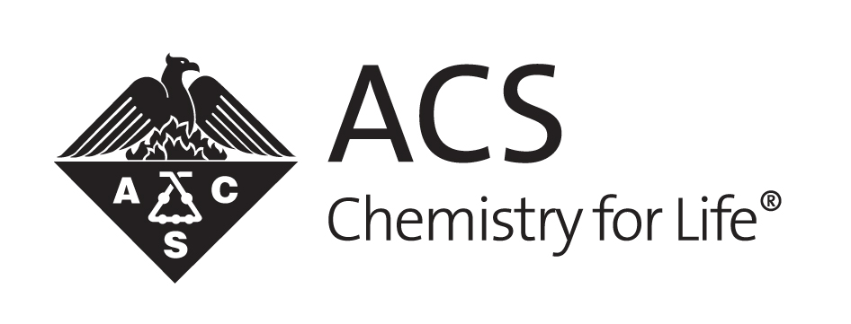
SHANGHAI International Chemical Sciences Chapter 2013 Annual Report

Minmin Wang, Jingye Zhou, Andrew Feng
2/11/2014

SHANGHAI International Chemical Sciences Chapter 2013 Annual Report

DESCRIPTION OF CHAPTER:
Shanghai International Chemical Sciences Chapter was established in 2011 by a group of oversea returnees from US. The group aims to serve the community by building a chemistry network in Shanghai and Yantze river delta. The primary goals for the chapter are connecting the people, education and making chemistry fun. The chapter is featured with strong industry connection from both pharmaceutical R&D centers and CROs.

Number of Chapter members:
30-100
Leadership team
Jingye Zhou (Chair, 2014)
Andrew Feng (Secretary, since 2011)
Minmin Wang (past chair, 2011-1013)
Chaoyu Xie (treasurer, 2011-2013)

ACCOMPLISHMENTS:
- Participated the ACS membership survey conducted by MCI Shanghai in January. Shared feedback and provided constructive suggestions on how to create sustained value to international members.
- Participated the first International Chapter summit at the 2013 Fall ACS National Meeting. Drs. Chaoyu Xie and Weiqiang Zhan participated the 1st international summit at the 2013 fall national meeting in Indianapolis. Shanghai team shared the priorities of the chapter and learned a lot of good practices from other international chapters.
- Hosted the visits of ACS International Activity Committee.
- Expanded the local chapter network to material sciences (led by scientists from Bayer Material Science) and Philips China.
- Held a joint meeting with Agriculture Division at Shanghai Jiaotong University with Professor Lianli Yu and Drs. Wally Yokoyama and Tom Wang on functional food.
- Established monthly chemistry head’s meeting in Zhangjiang Hi-Tech Park to further improve the communication and identify areas of common interests for the community.
- Chemistry demonstration at Shanghai American School as part of the 5th grade science program.
- Conducted a new round of Shanghai Chapter Executive Committee Election. Jingye Zhou was elected as a new Shanghai Chapter chair and has started the leadership role since Jan. 1 2014, Andrew Feng continues to serves as Chapter Secretary, new treasurer is still under searching.

MEETINGS HELD DURING THE YEAR:
No regular meetings due to difficult in commute. Most of the communication through emails.

PHOTOGRAPHS OF EVENTS:

OTHER:

PROJECTED ACTIVITIES FOR NEXT YEAR
1. Expand impact of ACS to broader China academic and industrial community by leveraging high profile conference with large population of participants such as ISCMC (International Symposium for Chinese Medicinal Chemists).
ACS Shanghai chapter will work jointly with ACS Northeastern chapter and ACS Maine chapter to contribute an ACS session (2-4 high profile speakers) to ISCMC meeting.

2. Initiate the introduction of Chemistry Olympiad to Shanghai International High School students.
ACS Shanghai chapter will work closely with ACS officials to enable the chemistry Olympiad testing in Shanghai.

3. Improve local chapter member communication, ACS local chapter awareness and member experience by setting up local social network and organizing local community activities.
Advance ACS local member communication by leveraging social media tools such as ACS networks or Wechat.
Organize a children’s outreach activity to engage both local members and children in an interactive event to advance chemistry if our proposal gains ACS sponsorship.

4. Enlarge member pools by recruiting new members and gaining back discontinued members.
Gain support from multinational pharmaceuticals based in Shanghai area to advocate member recruitment.

5. Career seminar
Organize a career seminar to provide consultation advices to graduate students in local community for careers in chemistry related industry (Pharmaceutical, CRO, Material Science, Food, etc)

CHAPTER OFFICERS AND CONTACT:
Jingye Zhou, jingyez@gmail.com, +86-15502162198
Andrew Feng, songfll@gmail.com, +86-13817279146
Minmin Wang, mw_20060309@hotmail.com, +86-13636516622

