The 2012
Clark County, Nevada
High School Chemistry
Poster Contest

Sponsored by the
Southern Nevada Section
American Chemical Society

At our December 13, 2012 meeting the winners of the ACS Southern Nevada Section high school student chemistry poster contest were announced. The prize winning posters are shown below on this page. The top three posters are listed in order. The next 8 Runners-up posters are in no particular order. Also listed are 14 additional posters that received Honorable Mention.

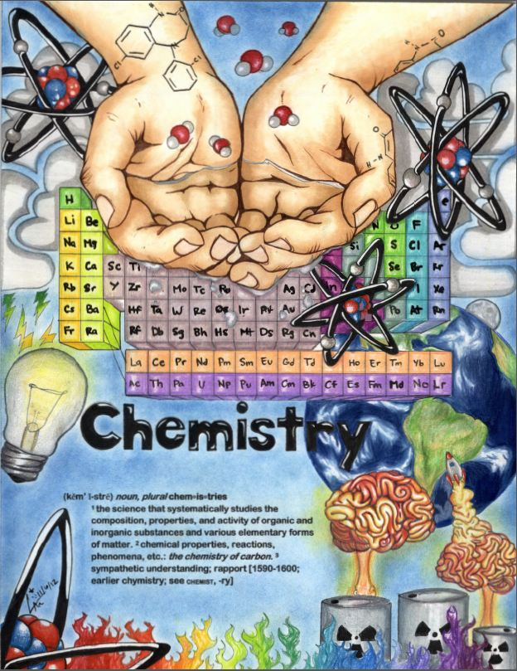
First Place, Shadow Ridge High School

Second Place Southeast High School

Third Place Foot Hill High School

The next 8 posters are all runners up, no particular order.

A. Runner-up, Chaparrel High School

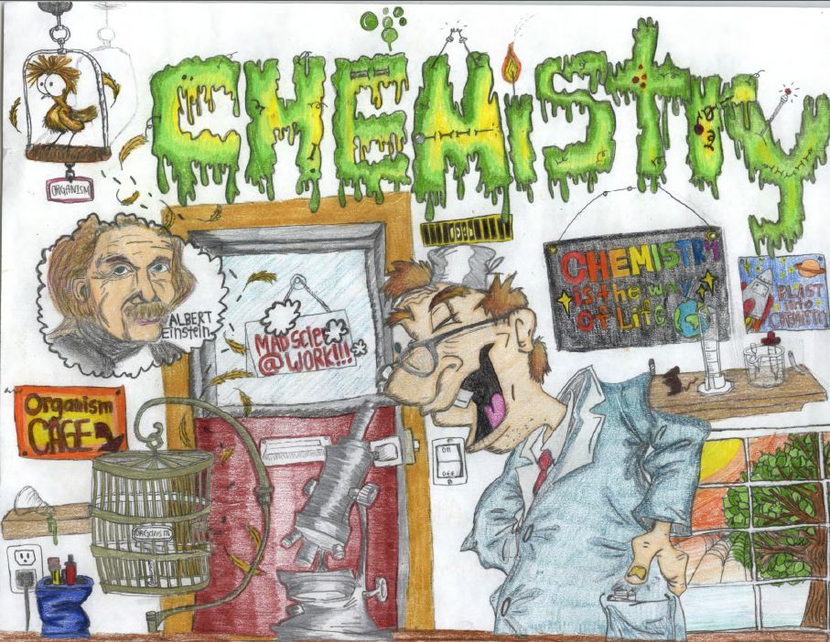B. Runner-up

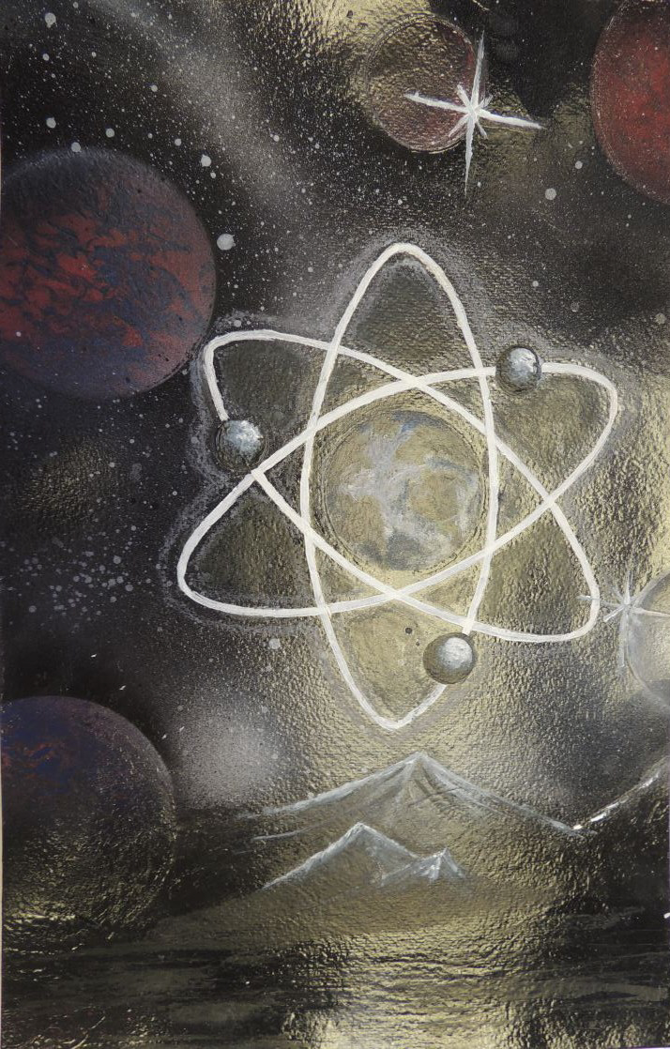
C. Runner-up, Green Valley High School

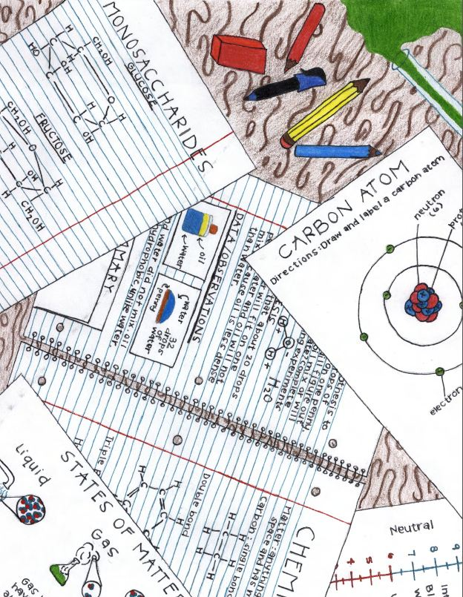 D. Runner-up, Northwest High School

E. Runner-up, Palo Verde High School

F. Runner-up, Rancho High School

G. Runner-up, SCETA High School

H. Runner-up, Western Prep High School

The next 14 posters got an honorable mention, no particular order.
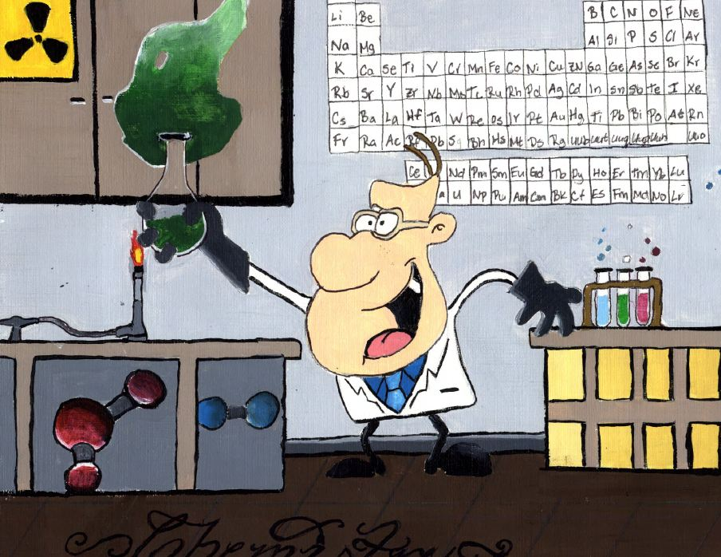A. Honorable Mention
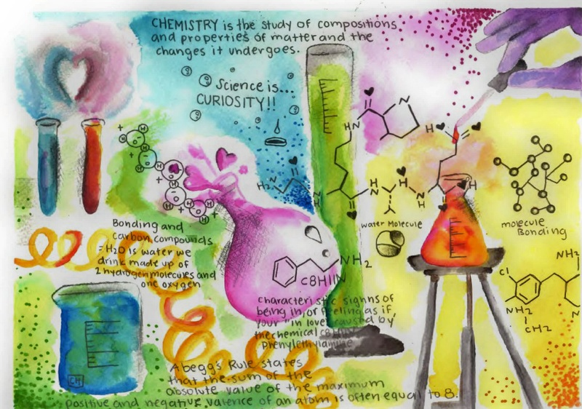
B. Honorable Mention

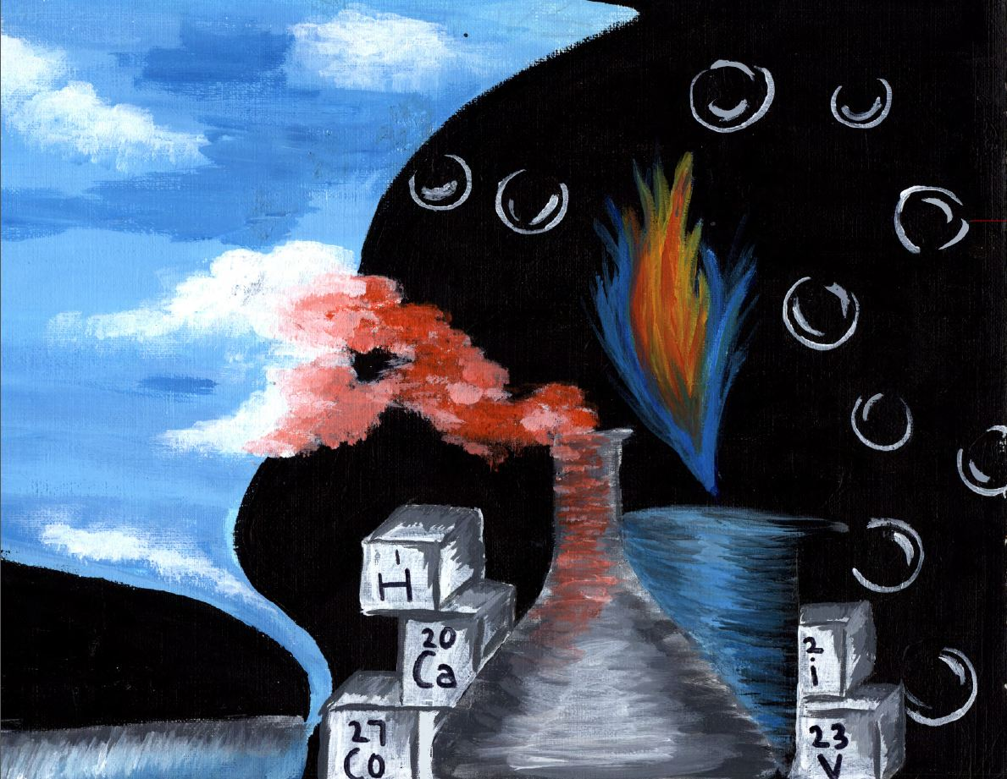
C. Honorable Mention
D. Honorable Mention
E. Honorable Mention

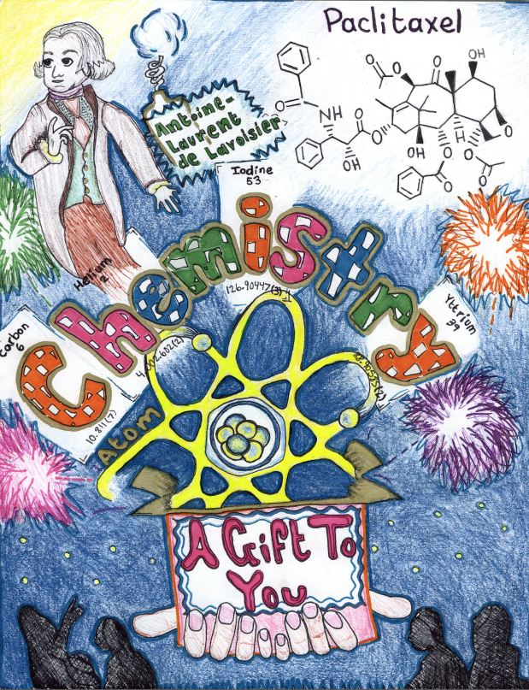
F. Honorable Mention

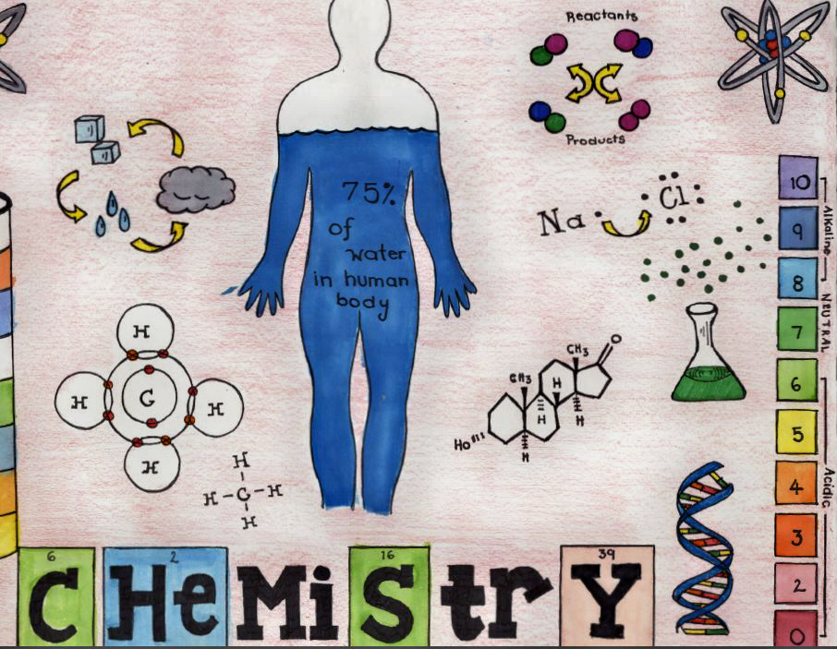
G. Honorable Mention

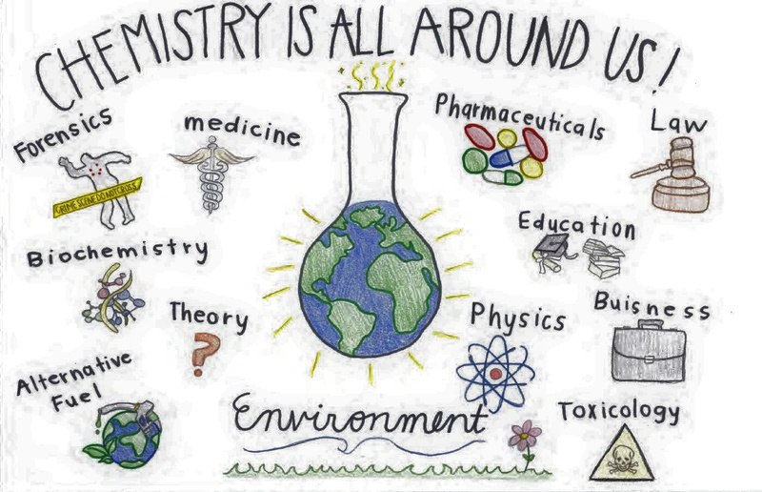
H. Honorable Mention

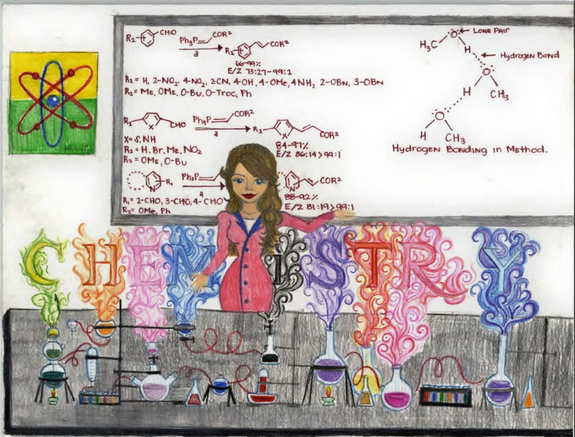 I. Honorable Mention

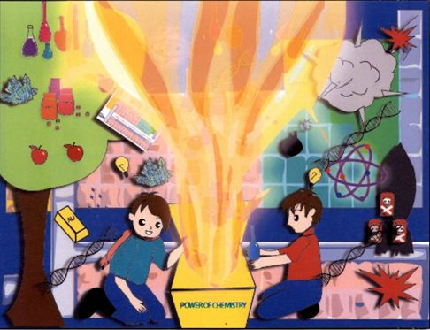
J. Honorable Mention

K. Honorable Mention

L. Honorable Mention
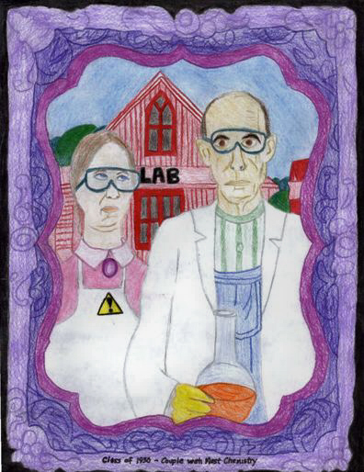
M. Honorable Mention

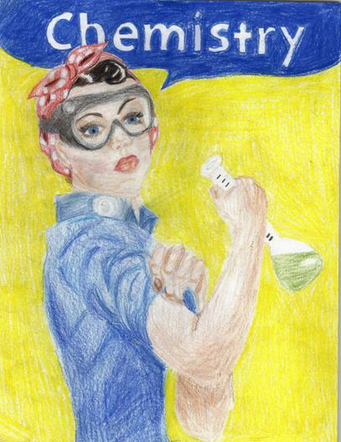
N. Honorable Mention
ACKNOWLEDGEMENT
The following people and organizations are thanked for their contributions toward making this years program a success.
- Judy Myers, Assistant Director, School-Community
Partnership Program,Clark County School District
- VWR International
- Executive Committee of the Southern Nevada Section
of the American Chemical Society
- All the high school students and teachers of the Clark
County School District who participated in this event

