2020 NCW Illustrated Poem Contest

Sticking with Chemistry

The Southwest Georgia Local Section of the American Chemical Society (ACS) is sponsoring an illustrated poem contest for students in Kindergarten through 12th grade.

Contest Deadline: October 25th, 2020

Prizes: Local Prize $50 for student and teacher on each category
Contact: NCW Coordinator, Linda de la Garza at ldelagarza@valdosta.edu
On Facebook: @ScienceSaturdayChemistryatVSU
Our website: https://communities.acs.org/community/society/component-websites/southwest-georgia
Submit your entry in the correct category and submit form with ALL fields at:
https://www.acs.org/content/acs/en/education/outreach/ncw/plan-an-event/illustrated-poem-contest.html

Winners of the Southwest Georgia Local Section’s Illustrated Poem Contest will advance to the National Illustrated Poem Contest for a chance to be featured on the ACS website and to win prizes!

Write and illustrate a poem using the NCW theme, “Sticking with Chemistry.” Your poem must be no more than 40 words and in the following styles to be considered:

HAIKU - LIMERICK - ODE - ABC POEM - FREE VERSE - END RHYME - BLANK VERSE
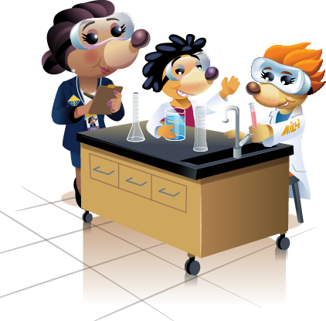
Possible topics related to the theme include:
Glue Slime Tape Adhesives
Geckos Polymers Adhesion Cohesion

Entries will be judged based upon:
- Artistic Merit - use of color, quality of drawing, design, and layout
- Poem Message - fun, motivational, inspiring about yearly theme
- Originality Creativity - unique, clever and/or creative design
- Neatness - free of spelling and grammatical errors

Contest rules:

- All poems must be no more than 40 words, and in one of the following styles to be considered: Haiku, Limerick, Ode, ABC poem, Free verse, End rhyme, and Blank verse.
- Entries are judged based upon relevance to and incorporation of the NCW theme, word choice and imagery, colorful artwork, adherence to poem style, originality and creativity, and overall presentation.
- All entries must be original works without aid from others. Poems may be submitted by hand on an unlined sheet of paper not larger than 11” by 14” or scanned and sent via email. Illustrations may be created using crayons, watercolors, other types of paint, colored pencils, or markers. The illustration may also be electronically created by using a digital painting and drawing app on a computer, tablet, or mobile device.
- The text of the poem should be easy to read and may be typed before the hand-drawn or digital illustration is added, or the poem may be written on lined paper, which is cut out and pasted onto the unlined paper with the illustration.
- No clipart or unoriginal images can be used.
- Only one entry per student will be accepted; all entries must include an entry form. If the illustration is created using a digital painting or drawing app, the name of the program must be included on the entry form.
- All illustrated poems and/or digital representations of the poems become the property of the American Chemical Society.
- Acceptance of prizes constitutes consent to use winners’ names, likenesses, and entries for editorial, advertising, and publicity purposes.

