10/28/2011
Press release
National Chemistry Week Poem Winners and Marie Curie’s Celebration Activities
The Southwest Georgia Section of the American Chemical Society (ACS) thanks the teachers in the area who submitted their student’s illustrated poems to the National Chemistry Week 2011 contest: Chemistry: Our Health, Our Future! The topics for the poems were related to chemistry and health such as vitamins, medicine, nutrition, and hygiene. A total of 124 students from thirteen schools were submitted in 4 categories and the winners were determined with the help of faculty from the English and Chemistry Departments of Valdosta State University on October 26, 2011. The best poem awards and $50 prizes went to: a) A’vyon West from West Town Elementary (K-2nd grade); b) Kyra Grier from W. G. Nunn Elementary (3rd-5th grades); c) Sara Knighton from Valwood School (6th-8th grade) and d) Kitra Cates from Lowndes High School (9th-12th grade). The best poems will represent the local section in the national contest in Washington, DC.
Honorary mention diplomas were awarded to: Tiwaloluwa Salami (Kindergarten) from Highlands Christian Academy; Catherine Morris (1st) and Victoria Goss (5th) from St. John School; Raven Ford (5th) from W. G. Nunn Elementary; Anna-Grace Grantham (6th) Coffee Middle School, Emma Parrot (8th) from Valwood School, and Michael G. Crozier (8th) from Thomas County Middle School.
The awards will be presented at the 100th anniversary celebration of the Nobel Prize in Chemistry to Madame Curie on Saturday November 12, 2011 at the Lowndes County Branch of the South Georgia Regional Library on Woodrow Wilson Drive, Valdosta, GA. From 3 to 5 pm there will be chemical demonstrations by VSU faculty, and children will test drinks for vitamin C and extract DNA. At 4 pm everyone is invited to learn about the Curie’s work in the special presentation of the 1997 movie The Animated Hero Classics: Marie Curie.
The general public may also attend the showing of the 1943 movie Madame Curie, on Friday November 11, 2011 at VSU’s Student Union Theater; at 6 pm. Books will be raffled among attendants.
For more information about the ACS local section activities visit the website: http://sowega.sites.acs.org, the Facebook page: Science Saturday Chemistry at VSU or contact Dr. Linda de la Garza at ldelagarza@valdosta.edu or (229) 333-5798.

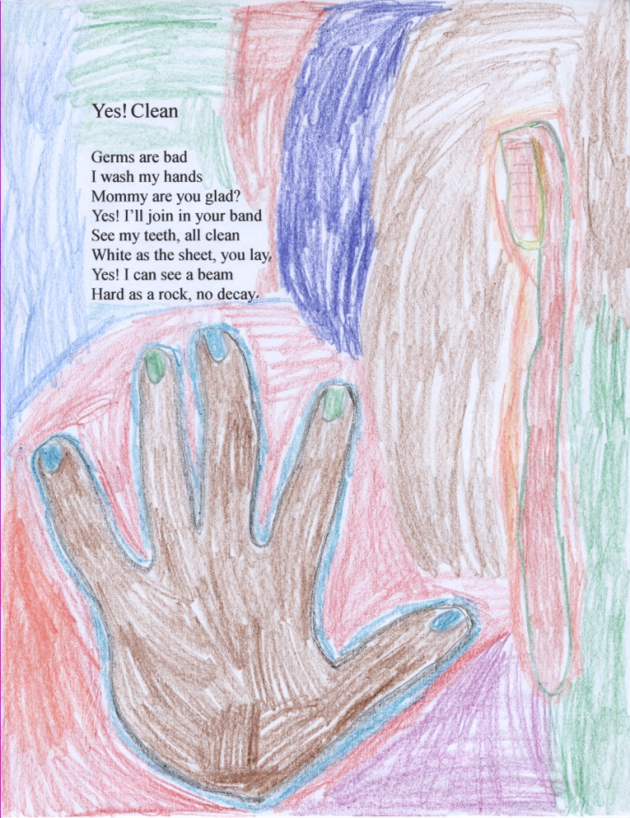
a) A’vyon West from West Town Elementary (Albany, GA)
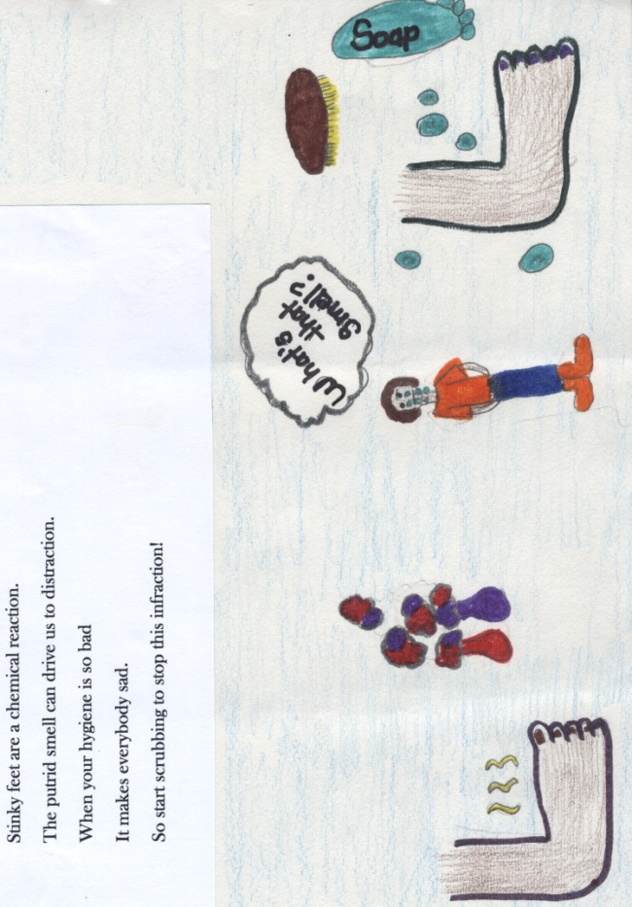
b) Kyra Grier from W. G. Nunn Elementary (Valdosta, GA)
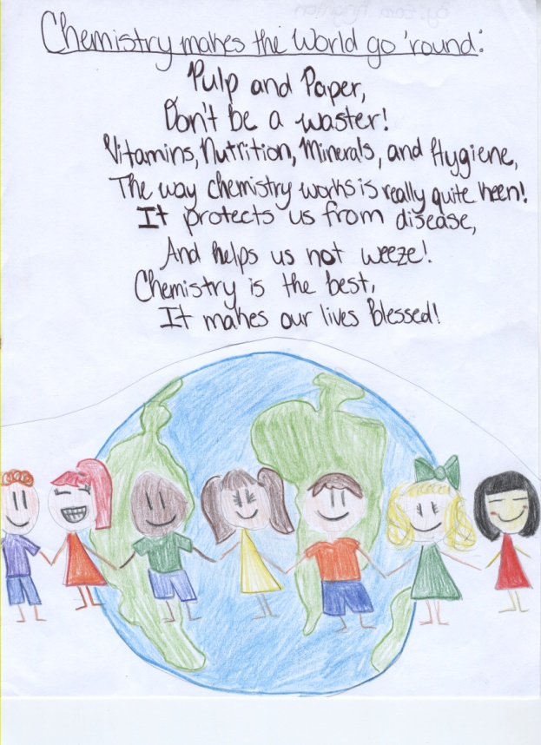
c) Sara Knighton from Valwood School (Hahira, GA)
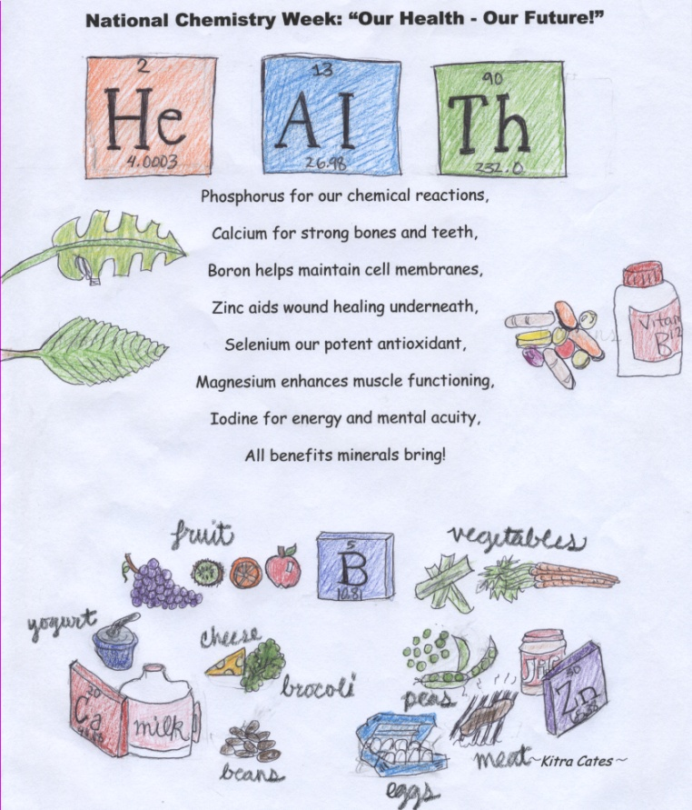
d) Kitra Cates from Lowndes High School (Valdosta, GA)
