Title: | Origami for leisure, origami for work!
Author:  Title and Organization: | Ressano Machado  Senior Lecturer, U of Wisconsin-La Crosse
Age Appropriateness: | ☐ 4th -- -6th grade  ☒ 7th – 9th grade  ☐ 10th – 12th grade
Flesh Kincaid Reading Level: | Use the readability statistics tool in Microsoft Word and insert the calculated reading level here.
Safety Suggestions: | ☐ Safety Goggles Required  ☐ Protective clothing suggested  ☐ Caution hot liquids  ☐ Do not eat or drink any of the materials used in this activity  ☐ Thoroughly wash hands after this activity  ☒ non-pointy scissors  ☐ Insert suggestion here  ☐ Insert suggestion here
Introduction of activity:
We use paper principally for writing and printing. Those thin sheets made of processed cellulose are great for storing information, thoughts and ideas for many years. Do you keep a diary? Then there are the toilet rolls or facial tissue that have become a necessity. The Japanese, instead have found other uses of paper; been folding paper to make paper sculptures for leisure, a practice called origami. You have perhaps tried origami in making a long flying paper rocket? Or has your science teacher made you separate sand and other slimy particulate from pond water using a folded filter paper placed into a funnel? Or perhaps you made “molecules” of paper?
Materials:
- paper
- scissor
- photo copier for the cellulose
Procedures:
Use this space to describe the process for participating in this activity. Also include any prep work required before the activity.

How does it work? / Where’s the chemistry?
No actual chemistry, but probably the first attempt at assembling a model molecule.

What did you see?
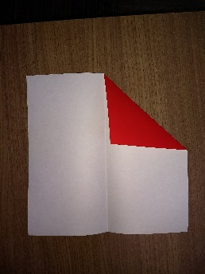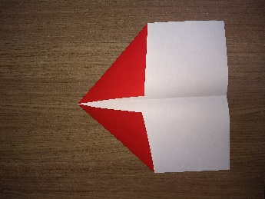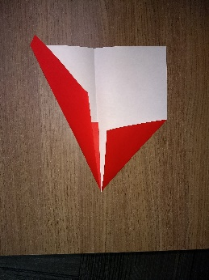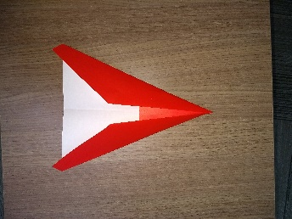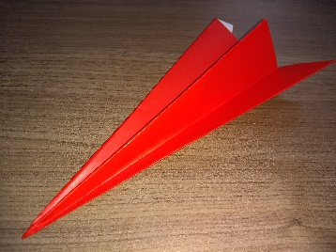
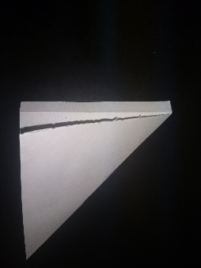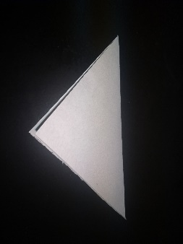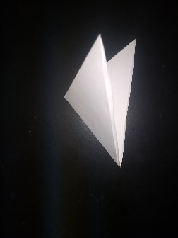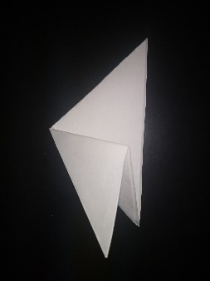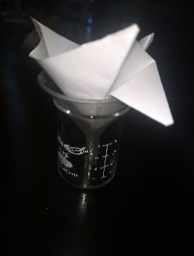
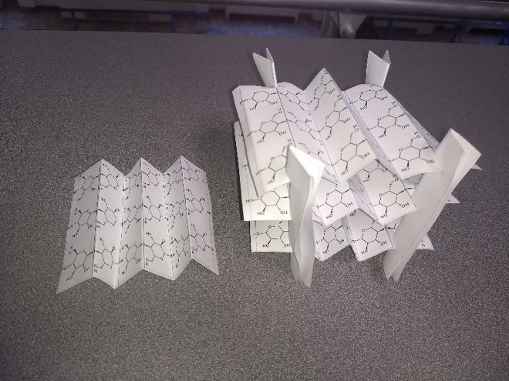
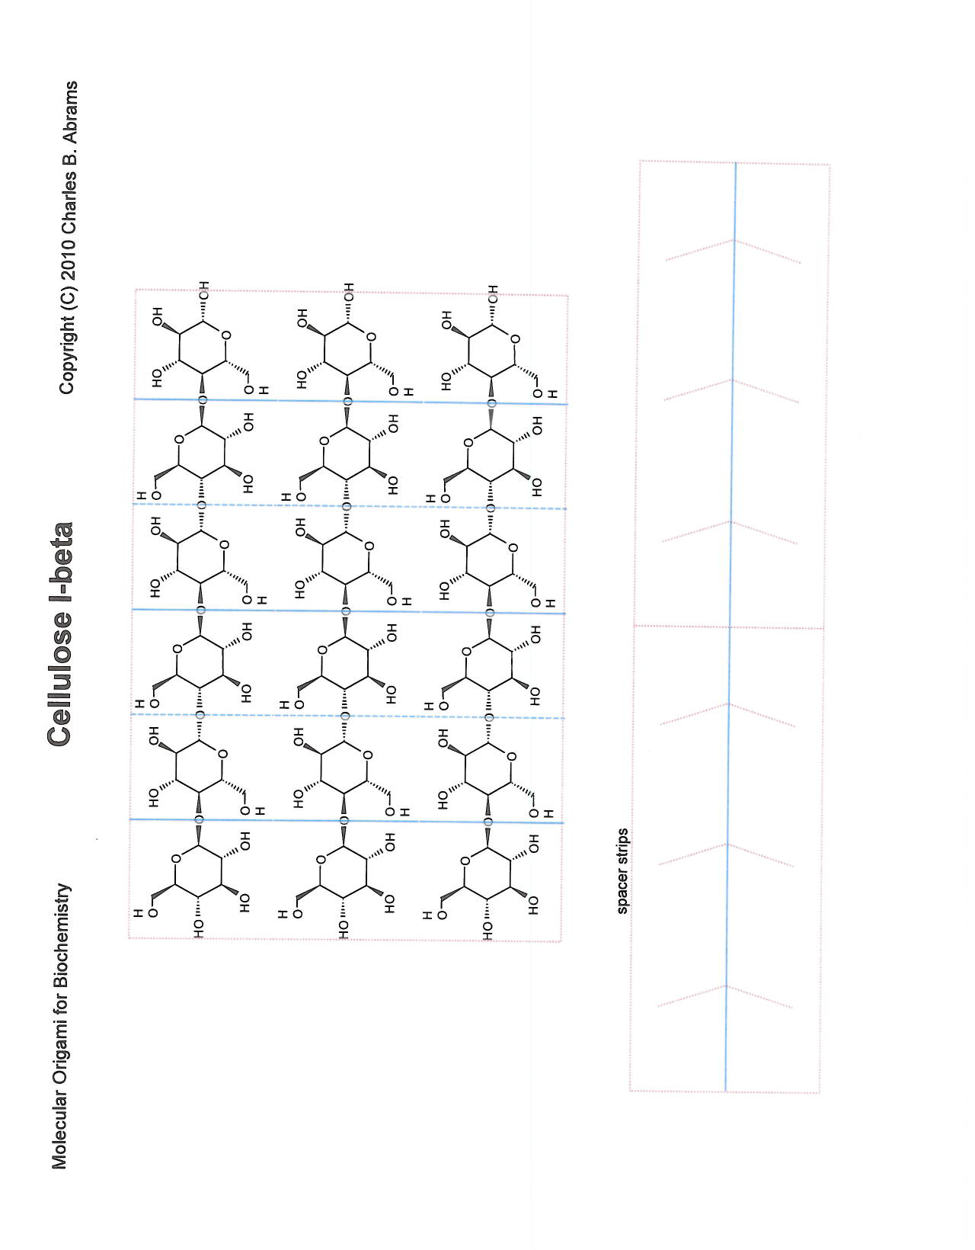

References:
Molecular Origami for Biochemistry, Charles B. Abrams (2010)
Artwork will be added to this activity to enhance the look and feel. You may optionally attach any suggested artwork for this activity. NOTE: It is your responsibility to secure copyright permission for any artwork/photographs that you suggest.

