Updating/Maintaining a Sub-forum with an Overview Page

Table of Contents:
- Key Terms & Definitions – p2
- List of Types of Content – p3
- Edit the Space’s Configuration – p4
- Post Announcements – p4
- Change the Layout – p6
- Add, Edit, or Delete Widgets – p7
- Create Content – p8
- Edit Content – p8
- Edit Banner design and Website Photo – p9
- Create Categories – p10
- General Notes – p12
- Recommended Reading – p12

The purpose of this document is to instruct Network users and section webmasters on how to interact with, edit, and manage a sub-space on the ACS Network with a specific navigation configuration of either “Activity + Overview” or “Overview.”

Key Terms & Definitions:
Space/Forum – This is a place within the ACS Network that acts as a website for local sections, technical groups, and other communities. Forums can be made public or restricted to certain users via permissions controlled by admins of the space. If a space is created within a main forum, that place is called a sub-forum or sub-space. The action of creating sub-spaces within parent forums is called nesting.
- Note: Only WSO can create a Forum/space. Contact them if you have the need to set one up.
Group – A group is an alternative type of Network space to a forum and it can be created by anyone. Groups can be made public, restricted, or private. When Private, a group is accessible to users via invitation only.
- Note: We are encouraging the use of forums over groups as they are easier to control and easier to support in the future.
Permissions – These are the settings prescribed to a specific forum or space that define whether or not a user, or group of users, is granted access to that place. A recently created sub-forum will inherit the permissions of the main forum it is in. Editing the permissions of a forum can make that space public or restricted, as well as give different users different capabilities in regards to viewing and editing the space.
Navigation – This defines the configuration of the sub-space and can be changed by an admin at any time. There are three types of different navigations. In this document, we are focusing on maintaining sub-forums that contain an Overview Page.
- “Activity + Pages” – Configures a stream-driven Activity page for the place, plus additional custom-created pages in a tabbed view. The left-hand tab is the default landing page.
    - Pages are different ways of exposing content (with your content being blog posts, documents, discussions, events, etc.)
    - This scheme is usually utilized for more complex sites that contain a lot of content. The content can be better organized using pages.
- “Overview” - Configure a widget-based Overview page as this place's landing page.
- “Activity + Overview” - Configure both an Activity page and an Overview page, either of which can be the landing page.
Landing Page – The page that is automatically displayed when navigating to a specific sub-space (the default page). When utilizing the “Activity + Pages” navigation, the landing page is usually set to be the page titled “Home,” but when using either of the other two navigations, the Overview page is generally designated as the landing page.
Tiles – Tiles are tools used to layout and expose content in a space on the Network. There are a variety of different types of tiles, each with their own respective function, but in general, they display specific types of content and allow users to interact with the site (ask questions, view videos/images, etc.). Tiles are used on both the activity page, as well as other customizable pages.
Widgets – Similar to tiles in the sense that they are tools used to design a Network space by displaying content and interacting with the space’s users. However, widgets are available only on the Overview page and are therefore not a concern when the page is set up to have an “Activity + Pages” Navigation.
Tags – Key, identifying words that organize content so that is more easily searchable by Network Users. Tags are able to be applied to a piece of content at any time and will never be displayed anywhere on a page. They are able to be used anywhere across the network and a single piece of content can carry numerous tags.
Categories – A way of organizing a specific space’s content into differentiable groups. Unlike Tags, categories must be created prior to applying them to content (opposite order for applying tags), and categories can be displayed on pages within a space. Additionally, while tags are used anywhere in the Network, Categories are specific to a group or forum.
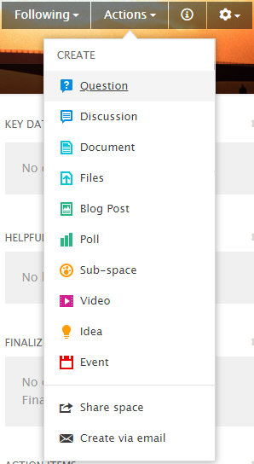
Actions – This refers to a list of things a site user can do to impact their sub-space. Some of these actions include creating content (such as a document, discussion, blog, etc.), sharing spaces, or sending content vCards via email. A more thorough description of the content users can create with the “Actions” list is included below:
Content
Question – Used to ask a question.
Discussion – Fosters collaboration and conversation among site users.
Document – Creates a document; can contain text and/or images. Usually used for static content.
Files – Uploads files from computer to LS sub-space.
Blog Post – Creates a blog post. Blog posts will be displayed on the overview (landing/default) page in chronological order as they are posted (as long as the page contains a “recent Blog Posts” widget). Used to share announcements.
Poll – Starts a poll that site users can answer. Good way to gather information of users’ preferences.
Sub-space* – This is a way to create a sub-forum to the main forum that is your website. This is only recommended when there is significant content that needs to be segregated from the main content. Permissions can be applied to control access to this area.
Video – Imports online videos to sub-space via URL.
Idea – Publishes Idea that others can comment on. Encourages ideation among users.
Event – Creates an event that will be displayed in the events tab and any “upcoming events” widgets or tiles.
*Forums and Sub-spaces can only be created by administrators; therefore, for most users, this will not be an option accessible via the “Actions” list.
How To
- Edit the Space’s Configuration: It may become necessary at any point in the process of updating a sub-space that the place navigation settings must be changed in order to accommodate your content. Sometimes it is better to have pages in order to separate different types of information, but other times an Overview Page is sufficient.
  - Changing the Navigation of a site:
    - Click on the gear icon in the top right corner of the page.
    - Access it’s dropdown list, titled “Manage,” and click on “settings.” After a few seconds a box should appear that is headed with the text “Edit Space: [Insert Space Name]”
    - Click on the “Advanced Options” dropdown list and choose the navigation option and “landing page” desired.
    - Once chosen, click “OK” in the bottom right corner of the Box displayed and then click save in the bottom right corner of the editorial window.
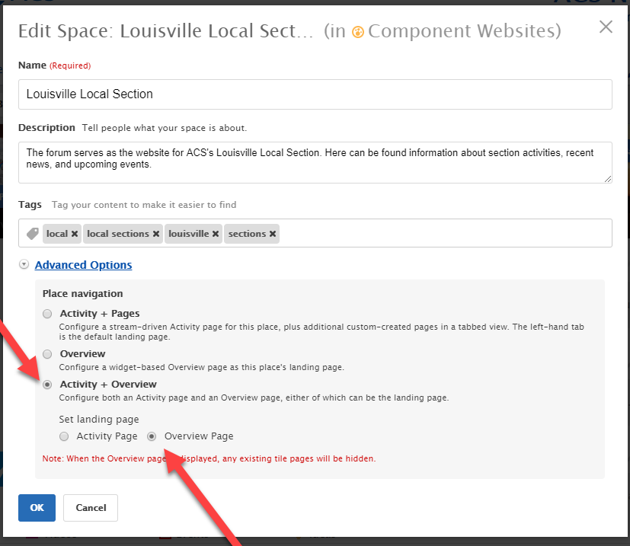

- Post Announcements: Adding a “Recent Blog Posts” widget to the Overview page is an ideal way for you to easily add current information to your page about upcoming events, awards, or other news your section needs to share. This widget will display a set number of recent blog posts in reverse-chronological order. Any blog posts created will be automatically displayed in the location of the widget; these posts can be used as announcements for your local section, hence the title “announcements” given to the widget shown in the screenshots below.
  - Creating a Blog Post
- Click on the “Actions” dropdown list within the right side of the site’s banner.
- Click on “Blog Post” under “Create”
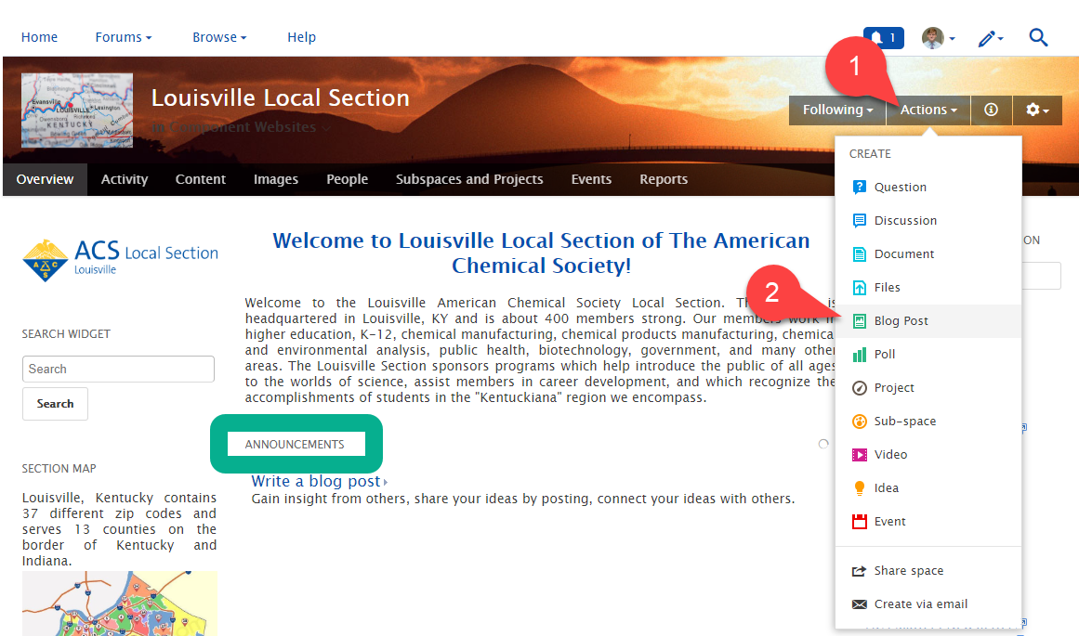
- Follow the instructions provided by the “create a new blog post” window
- Make sure that the “Publish Location” for the blog is the desired Local Section (Louisville Local Section) space, then click Publish; the blog will be automatically posted in the “Recent Blog Posts” widget that you can display on the Overview Page.
  - Changing the settings of the “Recent Blog Post” widget (i.e the number of items appearing or the title of the widget) on the overview page
    - Navigate to the editorial window by clicking on the gear icon in the right of the Site’s Banner and selecting “Overview Page” from the dropdown list.
    - Click on the triangle (pointing down) in the top left corner of the widget title announcements, and then click on “Edit this widget.”
    - You can change the title, the number of results the widget displays, and whether or not all of the blog’s content should be shown.
    - Make sure to save the new widget properties and to publish the page layout once finished, or else nothing will be saved.
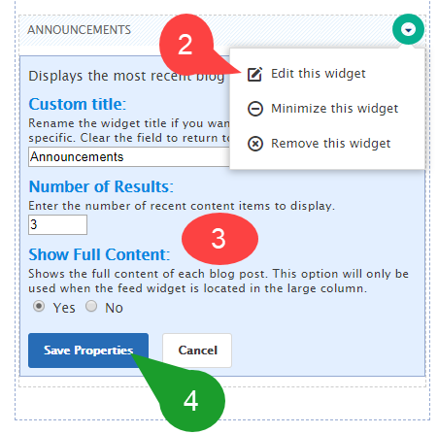
*Note: An announcement can be any sort of information you’d like to share with your colleagues, such as Upcoming Meeting information, local event invitations, new ACS content, etc. Usually, an announcement contains current information that is important for site users to see, while more static content that does not need to be regularly updated is usually published in a document form. Examples of static content are newsletters, annual reports, scholarship information, etc.

- Change the Layout: The layout of the “Overview” page determines the number and location of columns and rows used on the page. These columns/rows hold widgets, which displays content; therefore, the layout of the page directly effects the design of the page and how the content is organized.
  - Editing the layout of the overview page:
- Click on the gear icon in the top right corner of the page to get to the “Manage” Drop-down list
- Click on “Overview page;” an editing page for the Overview page should appear, allowing administrators of the space to edit it.
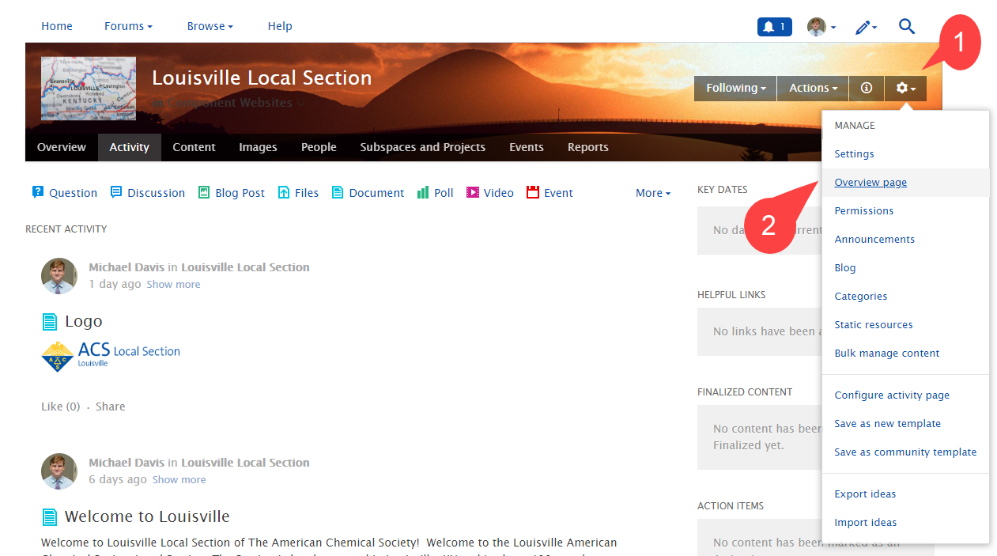
- Click on the desired layout preview displayed in the main blue editorial box at the top of the page (feel free to try a few out to see what works best for your content. Nothing is permanent.); the site will automatically reorder the widgets to account for the layout, but everything can be dragged and moved to your own specifications very easily
- To confirm and save the site’s layout, you must click the “publish Layout” button in the bottom left corner of the blue box (directly under the layout previews).

- Add, Edit, or Delete Widget: Widgets are used on the overview page in order to display various types of content and to provide viewers with a way to interact with the site.
  - Adding a widget to the overview page
    - Navigate to the editing window for the Overview Page (select Overview page from the “Manage” dropdown list displayed after clicking on the gear icon).
    - Select a widget of your choice from the blue editorial box (first select a widget category like ‘content’, ‘places’, ‘people,’ or ‘other’ and then choose the actual widget you would like to use).
    - A preview of the widget will be displayed in the editorial box; drag and drop the widget in the desired location on the page.
    - Edit the widget as desired and then click “Publish layout” when ready to save and publish the overview page
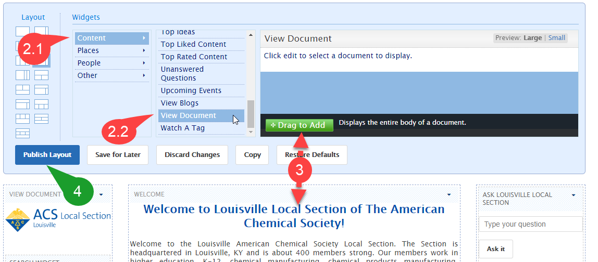

  - Editing, minimizing, or deleting a widget
    - Click on the triangle in the top right corner of the widget box and simply click on whichever of the three options you would like to perform (“Remove this Widget”, “Minimize this Widget”, or “Edit this Widget”).
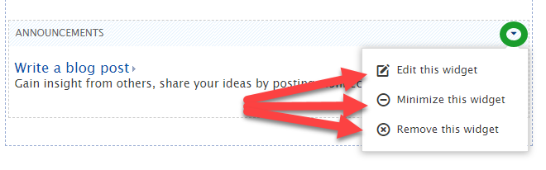
*Note: On the Overview Page, widgets are used to display content, but on the Activity page, tiles are utilized. Widgets are usually more user friendly and can be easily dragged and dropped, while tiles are more permanent in regards to their location.
- To configure the Activity Page, click on the gear icon in the right of the Site’s Banner and select the “configure Activity Page” option toward the bottom of the dropdown list.
- If you do not want an Activity Page, you can change the navigation of the site from “Overview + Activity” to just “Overview.”

- Create Content: There are many different types of content available on the ACS network such as blog posts, documents, files, videos, etc. Each type of content has a specific function. A list of common actions available to users is included in this document at the end of the “Key Terms and Definitions” section.
  - Creating and publishing/uploading content in the Network
    - Click on the “actions” drop down list in the right side of site’s banner, then select the desired content.
    - An editorial space, with instructions on how to create and edit the settings of the content will appear. Use the space and its instructions to create your desired content.
    - Publish the content in the space you desire to display it. Also, add appropriate tags to the content and consider including it in a category, so that is easily searchable by site users.
    - When finished, click the blue “publish” button at the bottom of the window.

- Edit Content: After creation and publication, content can be edited by the author at any time, and if the permissions allow it, it can also often be edited by other administrators/users as well.
  - Editing Content
    - Navigate to the “Content” Tab
    - Click on the title of the content (document, blog post, idea, etc.) you would like to edit
    - Click on the “edit” option above and to the right of the content preview.
    - Once editing is complete, click the “Update” button at the bottom of the page; if you do not, the content will not be saved.
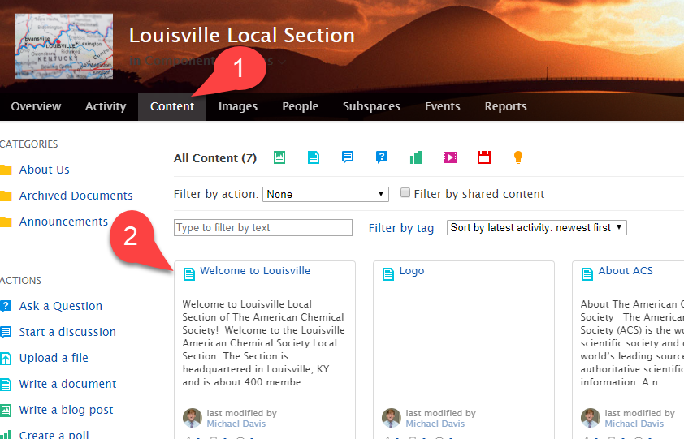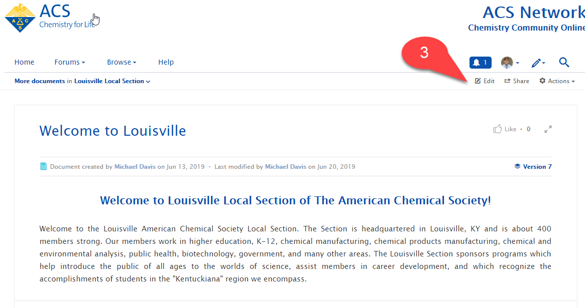

- Edit Banner Design and Website Photo: You have the option of changing the banner and image at the top of your website.
  - Editing the Website’s profile image
    - Click on the gear icon on the right side of the site’s banner. Access its dropdown list and select “settings.” A small window will appear that allows you to edit the Site’s Name, description, tags, and “Place Navigation.”
    - Exit the settings window that pops up and click on the blue button that reads “Place Image” underneath the current profile image.
    - Select the desired photo
    - Save the edit by clicking on the blue “save” button in the bottom left corner of the window.
  - Editing the Website’s banner
    - Click on the gear icon in the right of the banner. Access its dropdown list and select “settings.” A small window will appear that allows you to edit the Site’s Name, description, tags, and “Place Navigation.”
    - Exit the settings window that pops up and click on the blue button that reads “Banner Design” in the top right corner of the Banner.
    - Select the desired custom or preset banner design.
    - Save the edit by clicking on the blue “save” button in the bottom left corner of the window.
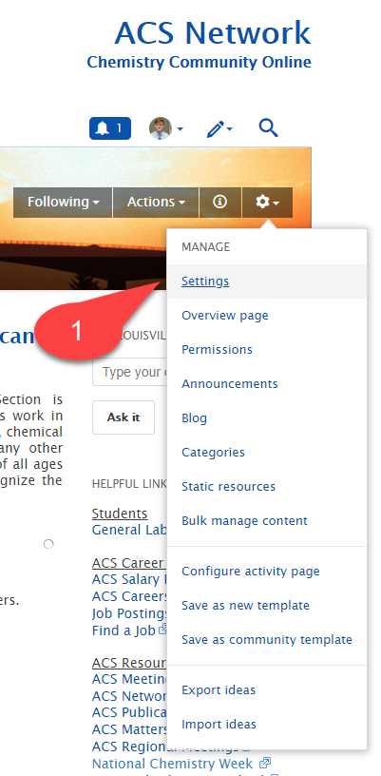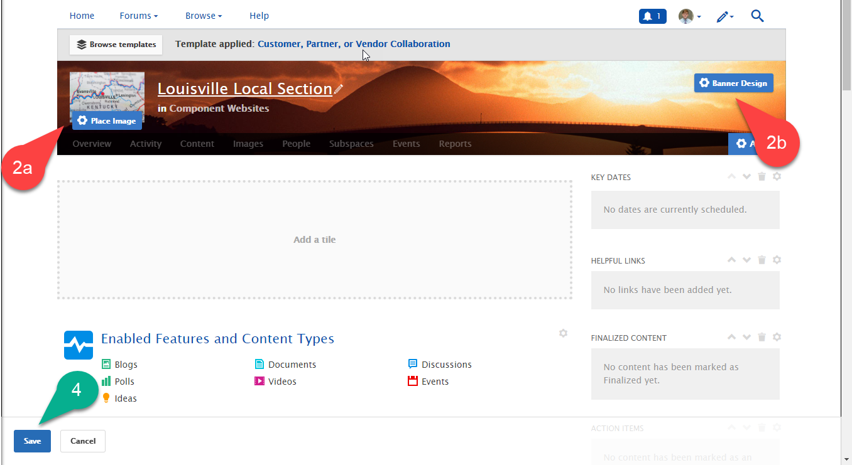

- Create Categories – Categories organize content of a specific sub-space by filing them away in groups. The categories must be created before being able to apply content to them.
  - Creating a category
    - Click on the gear icon in the top right of the window, and select the “categories” option from the “Manage” dropdown list. A “Manage Categories” box will appear.
    - Click on “Add a new category”; a new box should appear allowing you to create a new category. Give the new category a title and click the blue “save” button.
    - Click the white “Finished” button to return to the overview page
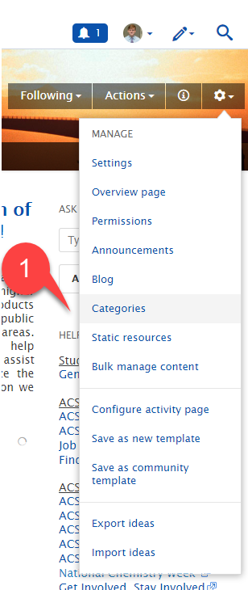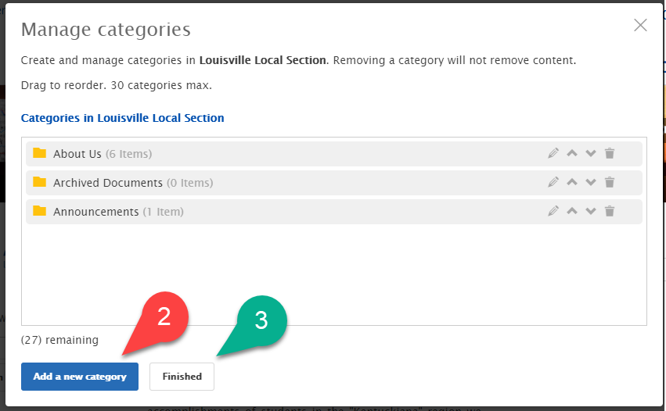
*Note: You can also alter the order the categories appear, change their titles, and delete them altogether using the “Manage categories” window shown in the screenshot above
  - Applying a single piece of content to a category
    - Navigate to the “Content” page by clicking on the “content” tab.
    - Click on the title of the content you would like to categorize
    - Click on the edit button above the content and then scroll down to the “categories” section of the “Edit This [insert content type]” page.
    - Select the check boxes to the left of the desired categories’ names.
    - Click the blue “Update” button at the bottom of the page.
  - Applying content to a category in bulk (adding multiple pieces of content to the same category at once)
    - Navigate to the “Bulk Manage Content” page (do this by clicking on “Bulk Manage Content” from the “manage” drop down list displayed after clicking on the gear icon).
    - Select the desired content by checking the respective boxes to the left of their names
    - Click on the file icon that reads “add Categories” when the cursor hovers over it; a box will appear allowing you to review the content chosen.
    - Click “continue” to proceed to the “add categories” window, and then check off the categories you would like to add the content to.
    - Click “continue” to finalize the categorization. Multiple pieces of content and categories can be chosen during this process.

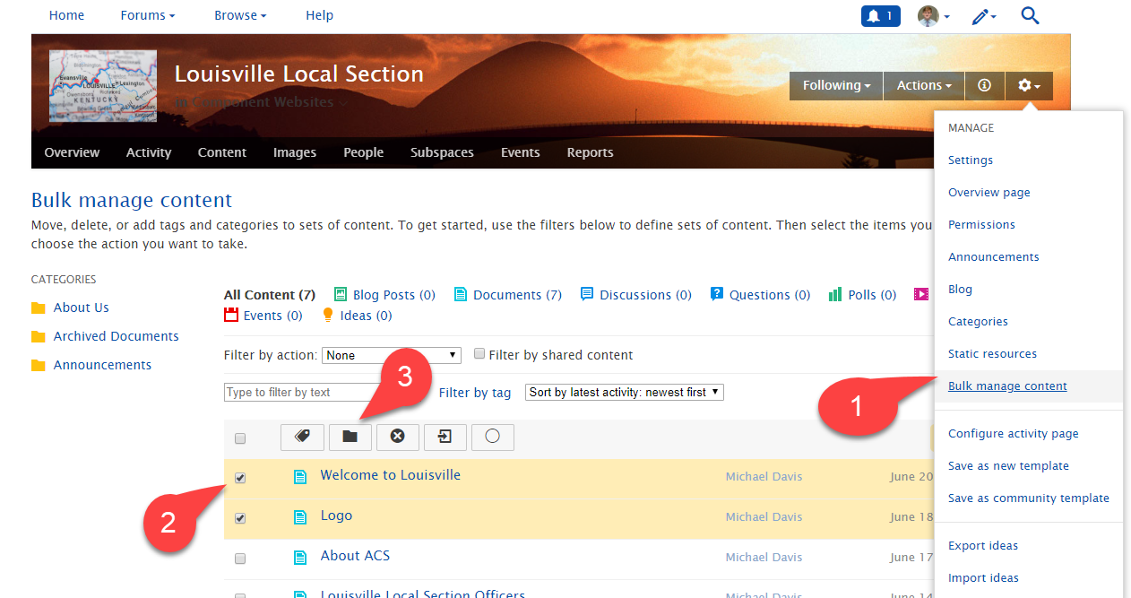
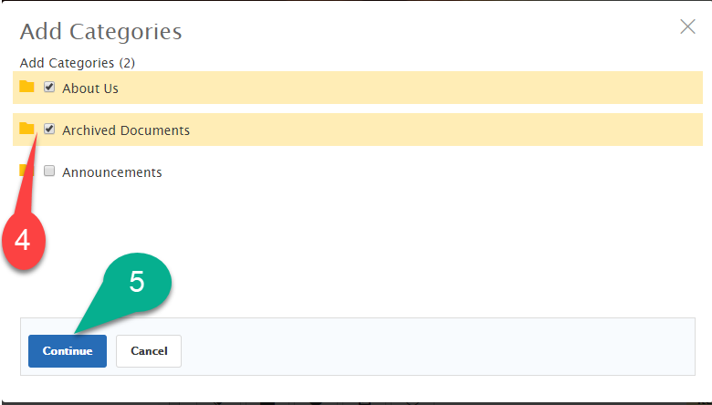
General Notes
General notes about using categories or tags: Always tag your content and add it to relevant categories! Any piece of content can be added to multiple categories, and can carry numerous tags. The use of categories and tags is intended to make content easier for Network users to find. Some helpful tags include keywords from the content being posted, the year/city/state of events mentioned in the content (i.e. national meetings), the names of people/awards mentioned, etc.
General notes for page configuring: Whenever editing widgets on the Overview page, be sure to click the blue “Publish Layout” button at the very bottom left of the light blue editorial box BEFORE leaving the site or navigating away from the page. If you forget to click this button the edits you’ve made to any of the widgets on the page will not be saved and your updates will be lost!

Recommended Reading
For additional Information on editing, updating, and moving Local Section Websites, please visit the following links from the ACS network and review the documents included on the page.
- https://communities.acs.org/docs/DOC-70859-general-functions-in-the-acs-network
- https://communities.acs.org/docs/DOC-71982-members-permissions
- https://communities.acs.org/docs/DOC-70860-recommended-tools-for-designing-a-streamline-groupforum
- https://communities.acs.org/docs/DOC-71890-migrating-from-webscom-to-the-acs-network-wabash-valley-example’
- www.acs.org/webhosting

