What is the Olympiad?

It's a nationwide competition to find the best Chemistry students in America. It is managed by the American Chemical Society and students write two tests. The first is at the end of March where the top students in each local area are found. These winners then take part in a national exam in April to find the best in America. Sophomores, Junior and Seniors can take part.

How does it work?

Volunteers from the local branch of ACS give one-hour classes once a week, usually from 7pm to 8pm from early January until the test in late March. They were done in a classroom until 2021 when they moved to virtual. In 2022 we hope to be back in class as much as we can. All our tutors are practicing Chemists and Engineers so we can add some examples of things we do to bring the things we teach in the classroom to real life.

What are the goals?

Find the best students who win cash prizes from the American Chemical Society.
Improve Chemistry grades.
Learn about careers involving Chemistry.
HAVE FUN

Who are we?

 | 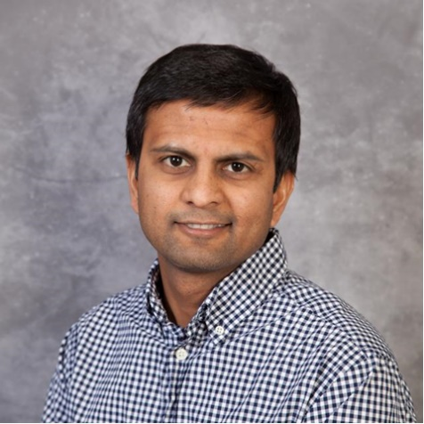
Mr Gary Layman. He is our link to Bartlesville High School where we give classes and he stays late, very late, on teaching nights. | Raj Kailasam – our webpage guy at the American Chemical Society

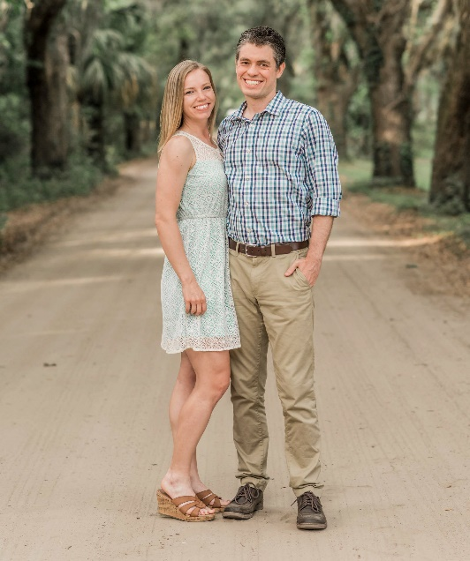
Laura and Dan Nielsen. Our so-cool tutors. | Keith Lawson. Program coordinator and tutor.  2022 will be my 11th year of doing the Olympiad and I love it. Teaching committed young students is a fantastic way to give back to Chemistry for the long and incredible career that it has given me.

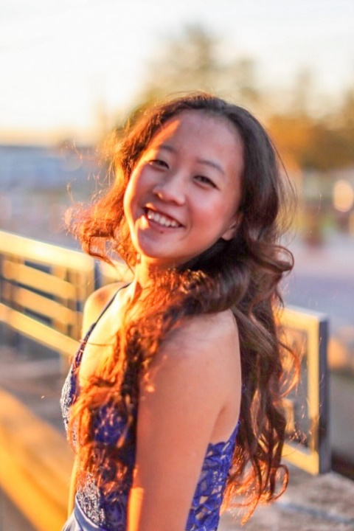
Rachel - Our top sophomore 2021 | Suchi-Top Junior 2021  The ACS Chemistry Olympiad has always been an insightful and eye-opening experience for me. Keith and his team have always demonstrated how Chemistry can be seen and applied anywhere in the world. Through the ACS program, I have developed a deep appreciation for Chemistry and my career choice involves applying Chemistry to everyday life!!
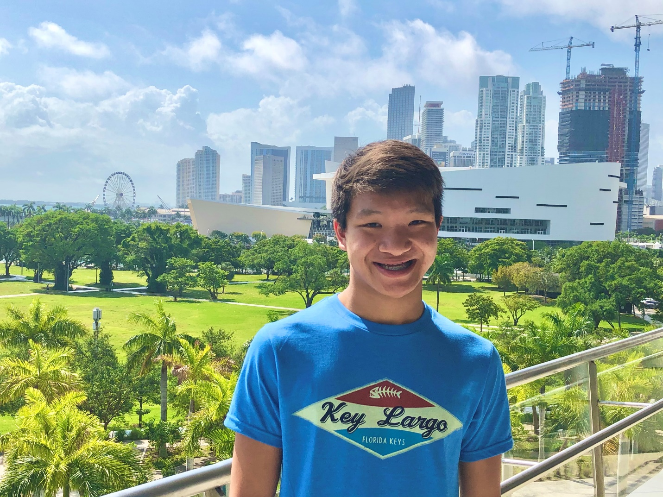 | Chemistry Olympiad is a great way to learn chemistry while having fun at the same time! It’s really interesting how much you understand after doing it.
Jarrett Moore – Runner-up Sophomore

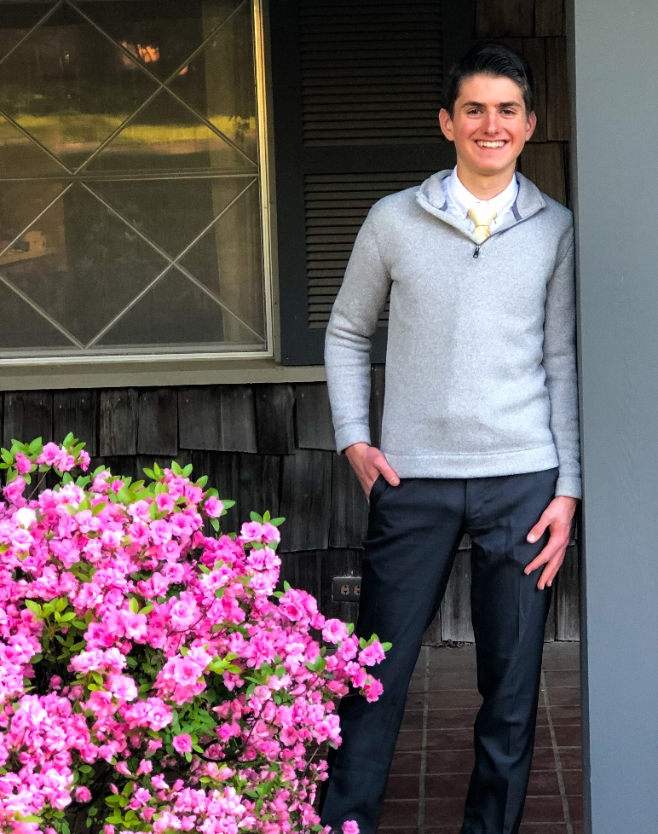
Morgan – Our overall Champion – two years in a row!

I love the Chemistry Olympiad! It is so interesting to see how the basic patterns and equations of chemistry can be used to explain so many properties, reactions, and real world processes. I learned a lot that I was able to use later in my chemistry class, and several of the best explanations I've gotten came from Chemistry Olympiad. Everyone should join!

How to sign up.

- Make a commitment to attend about 12 classes from January to March 2022. And when we say commitment, we mean it. We took this picture when the room where we planned to meet was closed and the students did class outside, in February! Go Morgan, Go Suchi!

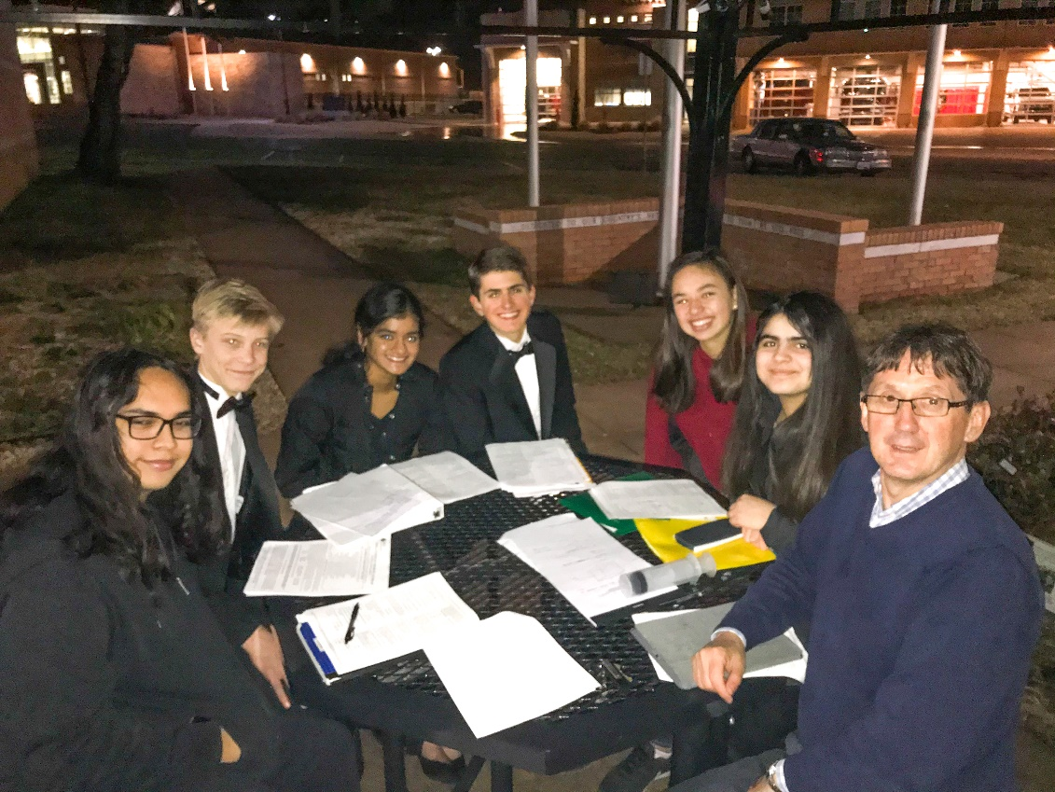
- Have access to a device that can work with a Zoom meeting for when we meet virtually.
- E-mail Keith at lawsonk58@gmail.com

