The 2014 high school chemistry poster contest is over. Over 150 entries were received this year. The three winners are:
First Place
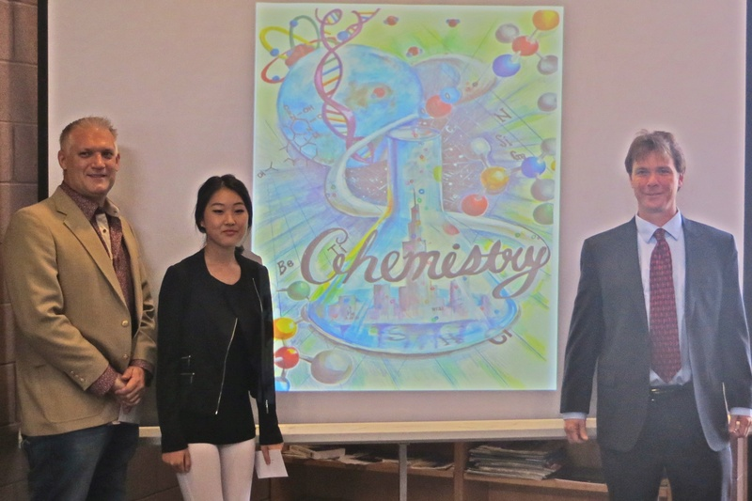

Second Place
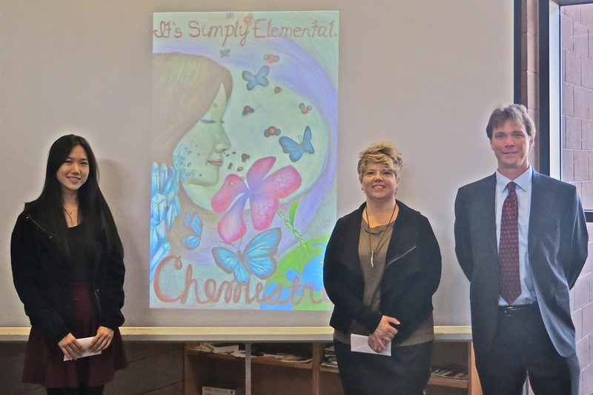
Third Place
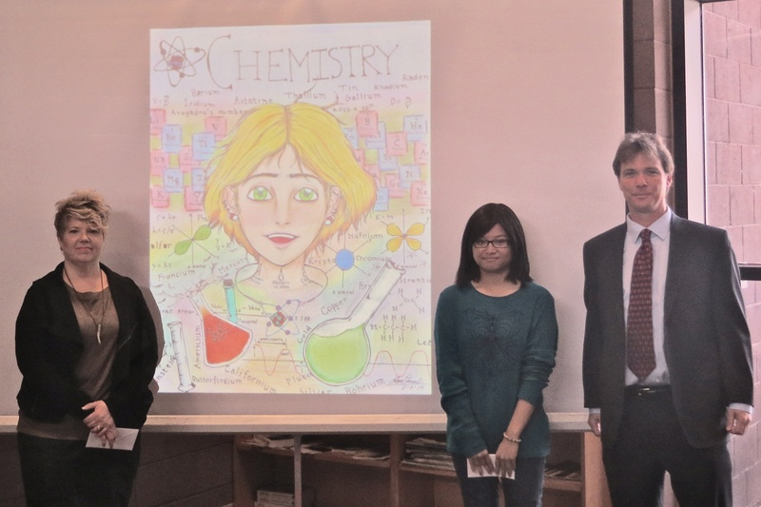

Under Graduate Research Poster Contest
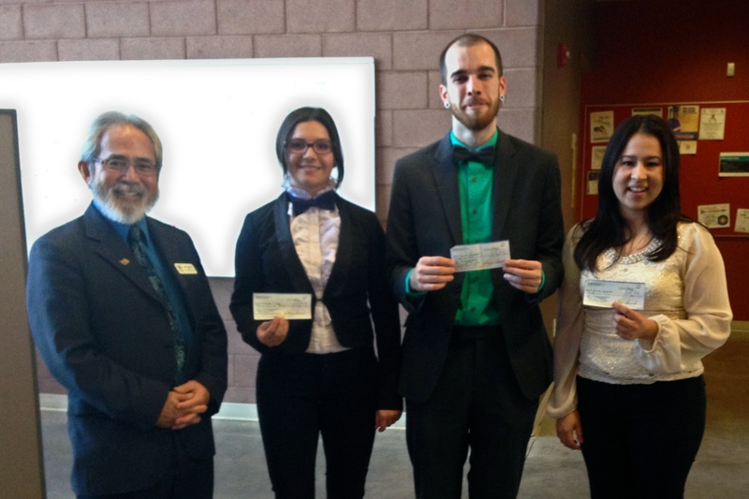
Dr. Kuihuki, Juana Garcis, Nevada State College, tied for 2nd,
Jacob Sorrentino, Nevada State College, tied for 2nd,
Mihalela Ciulei, University of Nevada Las Vegas, 1st

Graduate Student Research Poster Contest Winners
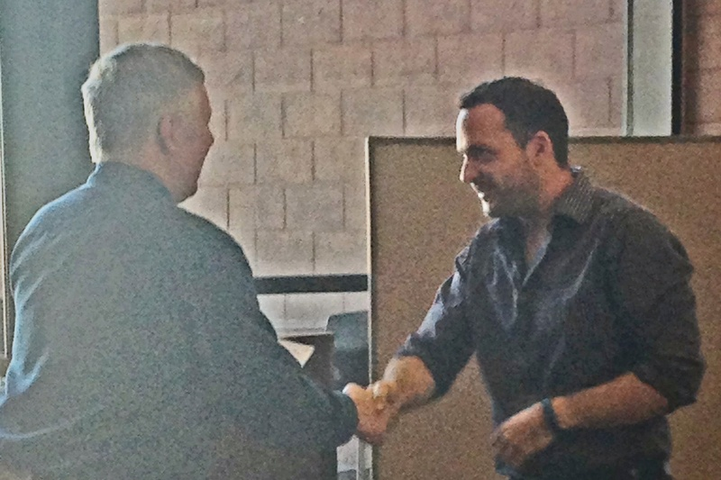
Dr. John Gerlach and Andrew Murishaw University of Nevada Las Vegas,1st

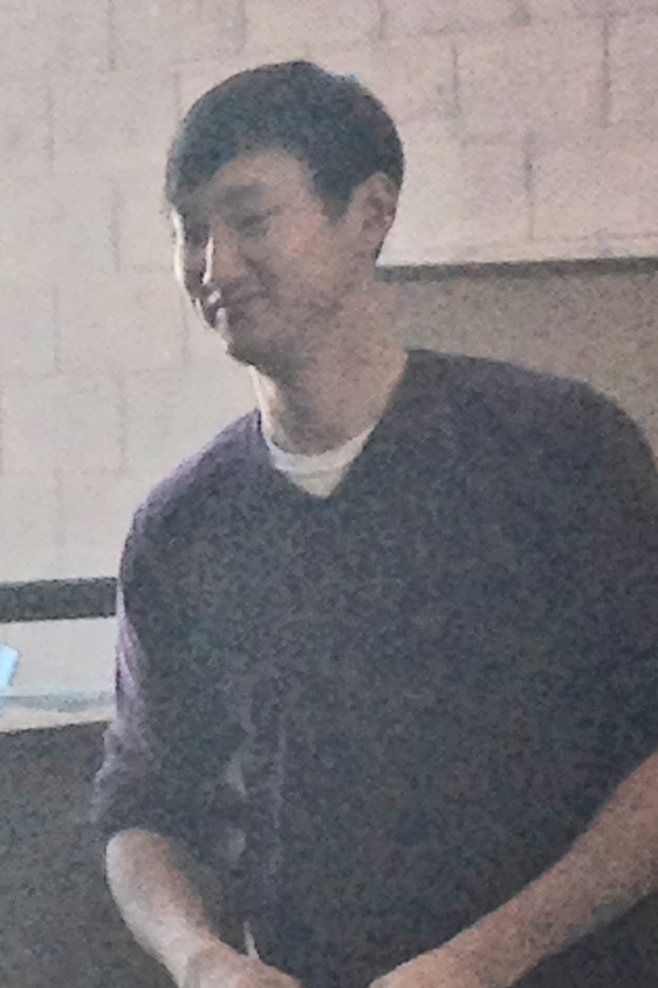
Jung Jae Koh, University of Nevada Las Vegas, 2nd

